Table of Contents

1. Introduction 5
1.1. Pattern of Obstruction and Sabotage 6
1.2. Growing Concern Within the Family 6
1.3. The Risk of Further Isolation 7
1.4. Concerns About Solange Richardson’s Capacity 7
1.5. Reflections on Vivian’s Support Needs 7
1.6. Request 8

2. Contact details: 9
2.1. Vivian’s Contact details: 9
2.2. Family contact details: 9
2.3. UK Doctor’s information: 10

3. Background on Vivian’s Mental Health Condition 11
3.1. Possible Traumatic Origins and Impact 11
3.2. Childhood Environment and Risk Factors 12
3.3. Cannabis Use and Clinical Deterioration 12

4. Summary: Clinical Phases of Vivian Richardson’s Illness 12
4.1. Baseline Remission / Partial Stability Phase 13
4.2. Prodromal / Escalation Phase 13
4.3. Acute Psychotic / Manic Phase 13
4.4. Crash / Depressive Post-Episode Phase 14
4.5. Remission / Reconstruction Phase 14

5. Risks to Vivian 16
5.1. Romantic fixations 16
5.2. “Living in the Matrix” delusions 16
5.3. Note on Masking and Diagnostic Complexity 16
5.4. Misperceptions of Support as Abuse 17
5.5. Undermining by Solange’s Reinforcement 17
5.6. Strengths and Vulnerabilities 17

6. Challenges in recent years: 18
6.1. Worsening symptoms from April 2023 onwards 18
6.2. Dismissal of Clinical Concerns by CMHT 18
6.3. Loss of Insight and the Illusion of Recovery 19
6.4. Social Engagement, Employment Strain, and Escalating Outbursts 19
6.5. Distorted Perception and Communication Breakdown 19

7. Sudden Decline in June 2024 20
7.1. Hospitalisations Since June 2024: 20

8. Initial concerns about returning to live with Mrs Solange Richardson 22
8.1. Early observed risks of instability observed in Mrs Solange Richardson 22
8.2. Religious Delusions, Emotional Volatility, and Coercive Control 23
8.3. Possible Generational Trauma and Unmet Mental Health Needs 23

9. Three occasions since January 2025 where Mrs Richardson has neglected Vivian when she needed care: 24
9.1. Mrs Solange Richardson’s Failure to act to help Vivian when she knew she was in acute psychosis - January 23rd 2025 24
9.1.1. Warning Signs Ignored in December 2024 24
9.1.2. First Critical Incident: Solange Acknowledges Vivian Is Unwell But Refuses Help (22–23 January 2025) 24
9.1.3. Emergency Response Triggered by Myself, Not Vivian’s Primary Carer 26
9.1.4. Acute Psychiatric Crisis Requiring Police Intervention (23 January 2025) 26
9.1.5. Solange denies Vivian needs to be in hospital and puts pressure on me to get Vivian released from psychiatric care as soon as possible 26
9.1.6. Inappropriate Pressure for Discharge During Acute Episode 27
9.1.7. Threat to Block Future Crisis Interventions 27
9.1.8. Claiming I “Jumped the Gun” in calling the police 28
9.1.9. Primary Carer’s Constantly Shifting Narrative 29
9.1.10. Contradictory Reasoning and Delayed Action in a Crisis 29
9.1.11. Vivian’s Gratefulness for my Intervention 30
9.1.12. Possible Motive for Obstructing Hospitalisation 31
9.1.13. Consequences of this neglect and safeguarding concerns: 31
9.2. Failure to act to help for Vivian when she knew she was in acute psychosis, and also actively blocking help getting to Vivian, causing Vivian to get into risky situations and trouble with the law - 3rd March 2025 to 13th March 2025 33
9.2.1. I Travelled to Florida to Oversee Vivian’s Release 33
9.2.2. Agreeing a Crisis Plan with Solange 33
9.2.3. Introduction of Vivian’s brother Jonathan Richardson into Vivian’s support network 33
9.2.4. March 3 2025 - Signs of illness emerging in Vivian again: 33
9.2.5. Solange is not cooperative with efforts to get help to Vivian 34
9.2.6. 3 March 2025 – Obstruction of the First Attempt to get the Crisis Team to Vivian 34
9.2.7. 4 March 2025 – Obstruction of a Second Attempt to get the Crisis Team to Vivian 34
9.2.8. Crisis Team call the Police due to Solange’s obstruction 34
9.2.9. Solange Tells the Police Efforts to get Help to Vivian are “Harassment” 35
9.2.10. Escalating Rejection of Support from Family Members 35
9.2.11. Undermining Crisis Response: Blocking Vivian from Accessing Law Enforcement Support 36
9.2.12. 12 March 2025 - Solange’s Delayed Attempt to Get Vivian Assessed for a Baker Act 36
9.2.13. Attempt for Crisis Team to reach Vivian at work 37
9.2.14. Another failed Police Baker Act intervention (with recorded evidence) 37
9.2.15. Successfully Baker Acting in another police jurisdiction 37
9.2.16. Vivian makes homicidal threats again 37
9.2.17. Consequences of Delayed Intervention and Ongoing Obstruction 38
9.2.18. Failure to Recognize Duty of Care and Disengagement from Support Role 39
9.3. Coercive Interference by Mrs. Solange Richardson in Vivian’s Attempt to Access Mental Health Rehabilitation – 19 March 2025 40
9.3.1. Coercive Behaviour and Threats of Eviction in Response to Mental Health Treatment 41
9.3.2. Malicious Allegations and Their Impact on a Vulnerable Adult's Safety 42
9.3.3. Wider Pattern of Emotional Abuse and Isolation of Support Figures 43
9.3.4. Further Observations over Coercive Control Dynamic and Housing Destabilisation 43
9.3.5. Concerns Regarding Carer Insight, Mental Health, and Impact on Dependent Adult 44
9.3.6. Consequences of Disrupted Treatment and Coerced Compliance 44
9.3.7. Lithium Use Agreed Under Questionable Circumstances 45

10. Additional Indicators of Risk and Carer Impairment 46
10.1. Coercive Interference with Immigration Status and Delusional Justifications for Medical Noncompliance During Vivian’s August 2024 Hospitalisation 46
10.2. Concerns About Delusional Thinking and Caregiver Fitness 47
10.3. Second UK hospitalisation September 2024: 48
10.3.1. Circumstances of second hospitalisation: 48
10.3.2. Solange’s Further Fabricated Claims and Denial of Clinical Reality 48
10.4. Reacting with surprise when Vivian got hospitalised almost immediately after returning to the US, and encouraging Vivian to drive despite the risks 51
10.4.1. Coercive Influence Leading to Unsafe Repatriation and Hospitalisation Risk 51
10.4.2. Encouraging Vivian to void her UK Visa Application 51

11. September to November 20205 - Coercive Disruption of Stabilisation Plan and Disregard for Immigration Consequences 52
11.1. 16th November 2025 - Hospitalisation in the US 52
11.2. Solange’s Disregard for Safety in Favour of Material Interests 53
11.3. 17 November 2025 - Vivian’s Expression of Regret and Early Signs of Reconciliation Before Relapse 53
11.4. Incident Involving Solange Attempting Harm to Neighbourhood Dogs and its Impact on Vivian's Mental Health Stability 53
11.5. Escalating Behaviour and Verbal Volatility Following the Dog Poisoning Incident 54

12. Incidents involving local garages leading to a divorce petition: 55
12.1. Escalation of Pressure and Paranoia Over Vehicle Repairs 55
12.2. Unsafe Expectations and Emotional Distress Over Car Repairs 56
12.3. 31 March 2025 - Second Solange Garage incident 58
12.4. Further Evidence of Emotional Abuse and Psychological Risk Posed by Mrs. Solange Richardson 60
12.5. Vivian’s Changing Position on Holding Her Mother to Account 60

Robert Wheeler
Apartment 12 Hockley House
23 Woolpack Lane
Nottingham
NG1 1GA
United Kingdom

Name of Vulnerable Adult | Vivian Richardson (32)
Diagnosis | Schizoaffective Disorder
Immediate Concerns | Psychiatric relapse; coercive control; sabotaged care; repeated hospitalisations; delayed or obstructed access to emergency intervention resulting in legal repercussions, financial harm, and psychiatric escalation including homicidal threats; erratic and grandiose behaviour by caregiver (Solange Richardson); possible untreated mental illness in caregiver.
Current Risk Level | High – based on three recent hospitalisations, escalating instability, and obstructed access to care
Primary Reporter | Robert Wheeler (husband and former primary caregiver)
Current Location | Residing with mother (Mrs. Solange Richardson) in the United States

Introduction
I am writing to respectfully request that Adult Protective Services open an investigation into the current welfare of my wife, Vivian Richardson, who has been residing with her mother, Mrs. Solange Richardson, since 3 November 2024. Vivian has a long-established diagnosis of schizoaffective disorder and, since at least August 2024, has been in a state of severe and prolonged psychiatric relapse. She has experienced a recurring pattern of sudden alienation from me (her primary caregiver for the past several years) followed by acute psychosis and eventual reconciliation after stabilisation. This cyclical dynamic has occurred during previous episodes and appears to be worsening in both frequency and severity.
While past relapses have always been distressing, the current pattern has reached a new and alarming level. Even before her return to the US her behaviour has approached the threshold of getting her into serious trouble. Vivian pushed a small child in public, causing a confrontation with the parent, she stepped in front of fast-moving traffic, and displayed severe disinhibition and hypersexuality, for example, removing her clothes in public view, exhibiting sexually aggressive behaviour toward her landlord, and undressing during a violent outburst while hospitalised.
Since returning to live with her mother, her condition has deteriorated further. On two separate occasions (23 January and 13 March 2025), she was hospitalised under the Baker Act after police recorded her making threats to kill. To my knowledge, Vivian had never made threats of this nature before. Prior to the most recent admission, she was also charged with dangerous driving, bringing her into direct conflict with the law. These incidents mark a dangerous escalation in her psychiatric symptoms and represent an immediate risk to her safety and the safety of others.
In this report, I will demonstrate how, despite these alarming events, Mrs. Solange Richardson has repeatedly refused to cooperate with concerned family members and has actively resisted appropriate interventions. I will show that on multiple occasions she has failed to seek help even when Vivian was in an obvious state of psychosis, and that she has obstructed efforts to involve crisis teams, with consequences that are serious and sometimes dangerous. Solange’s unwillingness to recognise Vivian’s clinical deterioration, combined with a pattern of rejecting professional advice, has led to delayed or denied emergency interventions. This has often requiring myself and others to act remotely and under pressure.

Pattern of Obstruction and Sabotage

Beyond failing to seek timely care, this report will evidence that Mrs. Richardson has gone so far as to sabotage Vivian’s access to longer-term rehabilitative treatment. Most notably, in March 2025, Vivian and her brother Jonathan arranged for her to attend a residential mental health rehabilitation programme. On the day of arrival, Mrs. Richardson threatened that Vivian would be “killed and raped” at the facility and implied she would be made homeless for attending. Vivian left the programme after just one night and later asked me to apologise to her mother on her behalf. This pattern of control and intimidation is deeply troubling and, I believe, impeding Vivian’s recovery.

Growing Concern Within the Family
I am submitting this report after consultation with members of Vivian’s extended family, many of whom share my concerns. At present, Vivian is estranged from me, a pattern that has occurred during previous episodes of illness, but I have reason to believe she is not currently acting with full autonomy. Her recent deference to her mother’s will, particularly in abandoning a clinical programme she had agreed to attend, indicates that Vivian may not be able to exercise independent judgment.
It was while reviewing documents related to divorce proceedings (served by Vivian during this current period of estrangement) that I came across police records detailing the threats she made during her last two Baker Acts. These records, along with other evidence of Solange’s increasingly erratic behaviour, made clear the extent of neglect and obstruction now taking place, making this report an urgent necessity.
Given Solange’s hostility and her apparent hold over Vivian, it is most appropriate for me to submit this report, given my historical caregiving role and current estrangement from Vivian. This will hopefully limit the risk Vivian estranging from further family members such as her brother Jonathan Richardson, in reaction to it being raised.

The Risk of Further Isolation

Vivian was previously cut off from her paternal family by her mother between the ages of 7 and 17, and we are concerned that this isolating pattern may repeat. Solange’s estrangement from her own family, and her hostility toward anyone attempting to support Vivian, increases the risk that Vivian will become isolated from other relatives who have her best interests at heart. To assist any investigation, I have included a list of family members who I would urge you to contact. Some are aware of this submission; others are not. I believe those who do respond will give honest and constructive perspectives.

Concerns About Solange Richardson’s Capacity
Although Vivian has, in the past, acknowledged her mother’s emotional abuse and neglect, I do not believe she is currently able to recognise these patterns. I am also concerned that Mrs. Richardson may be suffering from an undiagnosed long-term mental illness herself. She is estranged from most of her extended family and this report will document and evidence outlandish accusations she has made against us. This report will document and evidence Solange’s increasingly unstable and paranoid behaviour, including confrontations in her local community and grandiose religious claims she has made, including the apparent belief that she can invoke cancer in people via God..

Reflections on Vivian’s Support Needs
One of the most difficult dilemmas is that although Solange Richardson is clearly not a suitable long-term carer, there is a concern that Vivian may not currently be able to live independently. She needs supervision and companionship. During manic phases, she is highly susceptible to external suggestion and manipulation, and her condition can escalate dangerously within days and hours. In my opinion, her brother Jonathan Richardson would be the most appropriate person to provide interim support in the event of any change in her living arrangements, though he would require additional assistance to do so effectively.

Although I would be willing to support my wife in the future, I would say at this point I have become such a focus for the negative aspects of Vivian’s illness that it would be difficult for me to offer this at this time. I continue to honour my vows “in sickness and in health”. However, being pragmatic, in order for me to consider supporting Vivian in the future, she would need to have gone through some form of rehabilitation and have had the time and space to come to an independent conclusion that she would want me in her life. As things stand I think this is unlikely to come to pass, although I would be willing to participate if decisions needed to be made and Vivian was lucid enough to ask for me to assist. In the last year Vivian has repeatedly alienated from me for weeks and months at a time, only to suddenly appear and ask for me to support her, so it is not as far fetched as it may seem that she might turn to me again.

I am not contacting APS out of personal interest in reconciliation. This will likely make the situation between myself and Vivian worse. My concern is for Vivian’s safety, autonomy, and long-term wellbeing.

Request
I respectfully urge APS to:
- Assess whether Vivian currently has the insight and capacity to make informed decisions about her health, safety, and living arrangements.
- Open a formal investigation into the current caregiving environment and whether Vivian’s rights, safety, and treatment needs are being adequately met.
- Conduct a welfare check and clinical evaluation, taking into account her recent hospitalisations and concerning behaviours.
- Evaluate the influence and actions of Solange Richardson, including her role in obstructing care, rejecting professional recommendations, and potentially exerting coercive control over Vivian.
- Establish independent oversight of Vivian’s mental health care moving forward, including the reinstatement or creation of a long-term treatment and safeguarding plan.
- Facilitate engagement with mental health services or other suitable interventions to reduce the risk of future harm and ensure that Vivian is not isolated from healthy family or community supports.

Contact details:

Vivian’s Contact details:
Vivian Lynn Barreto Richardson
DOB: 24th January 1993
Address: 904 SW 5th Avenue, Boynton Beach, FL 33426 (last address I am aware of, they may have just sold their home).
Tel: 561 248 7066

Mrs Solange Richardson is at the same address and her telephone number is 908 797-4708

I reside in the at Apartment 12, Hockley House, 23 Woolpack Lane, Nottingham, NG1 1GA, UK
I have a US phone number on 561 903 4124 that forwards to my UK mobile number. I will always try to pick this up at any time night or day wherever I am in the world.
I can also be reached on +447486888084 (but that will be an international call).

Family contact details:

This is a list of Vivian family members whom I hold contact details for that may be useful in your investigations. They may be able to provide further contacts:

Mr Jonathan Richardson (Vivian’s brother)
Address: 14 Kings Village, Budd Lake, New Jersey 07828
Tel: 201 9532 807
Email: Johnnyleerich@gmail.com

Mr Daniel Richardson (Vivian’s father)
Address: 2694 Night Shade Blvd, Galena, Missouri 65656
Tel: 973 350 4324
Email: pqqamazon@yahoo.com

Ms Caetlynn de Oliveira (paternal cousin and a practicing nurse who has taken an active interest in Vivian’s welfare, who has been involved in her hospitalisations in the past, and who visited us in the UK just three weeks before Vivian suffered a big downturn in her health).
Tel: 6073178923
Email: oliveicat@gmail.com

Mr Andrey Conte (Maternal cousin. Andrey is resident in the Republic of Ireland and visited us at our home in the UK and we visited him in Ireland. He has also been involved in trying to get help to Vivian at times of crisis).
Tel: +353 86 456 3121 (please note that this is a Republic of Ireland phone number).

Mr Romulo Barreto (Maternal uncle of Vivian and brother of Mrs Solange Richardson)
Tel: 973 954 6225

Ms Cara Kennedy (partner of Vivian’s brother Mr Jonathan Richardson – she made the call to the police on Vivian’s last Baker Acting)
Address: Address: 14 Kings Village, Budd Lake, New Jersey 07828
Tel: 973 487 6396

UK Doctor’s information:

Vivian’s NHS Mental Health Doctor in the UK between November 2021 and November 2024 was Dr Jolly who works as part of the City East Mental Health Team, Lavender House, Porchester Rd., Nottingham NG3 6LF.
Emails should be marked “FAO: Dr Jolly” and sent to CityEastAdmin@nottshc.nhs.uk

My understanding is that due to Vivian’s past testimony, Dr Jolly was so concerned about Vivian’s proposed return to the US to live with her mother that he considered hospitalising her to prevent her leaving the UK.

Background on Vivian’s Mental Health Condition

2012 - First episode and delusional fixations
Vivian experienced her first episode of psychosis in 2012, at the age of 19, following the breakdown of her first significant romantic relationship. This relationship became the focus of delusional fixation during subsequent relapses over the next several years. Vivian explained to me that around 2018 or early 2019, she was watching an episode of the Alex Jones podcast and Paul Joseph Watson said the words “rubber ducky”. For some reason, she had some kind of epiphany and the fixation transferred to him
This specific fixation has remained active during relapses and has even been integrated into Vivian’s coping strategies. Notably, she devised a plan while well to store emergency antipsychotic medication inside a book by Watson which she knew she would only read if she became unwell. She placed a note alongside the medication instructing herself to take the medication “and thank yourself later” if she ever found herself reading it. Remarkably, during her two most recent episodes of psychosis, Vivian rediscovered this message and took the medication despite having no memory of writing it. Unfortunately, on both occasions, it was not sufficient to reverse the episode. However, given the chance and appropriate attention, I suspect that this aspect of Vivian’s illness is very treatable.

Diagnosis revision to Schizoaffective Disorder and move to the UK
The majority of Vivian’s psychiatric care has been limited to crisis stabilisation and follow up outpatient appointments. In 2019, Vivian’s diagnosis was revised from bipolar disorder to schizoaffective disorder, reflecting the psychotic elements alongside mood instability. Between 2012 and 2021, she experienced multiple hospitalisations. We moved from the US to Nottingham, UK in November 2021. From April 2021 to June 2024, Vivian had three years of remission from psychosis, supported by early interventions from the UK’s Community Mental Health Team. She lived with me throughout this period as my wife, and I was her registered caregiver.

Possible Traumatic Origins and Impact

Vivian’s mother, Solange Richardson, has disclosed to me that Vivian may have experienced a serious sexual assault between the ages of 16 and 17. According to Solange, Vivian was lured to an address by a female friend and assaulted by a man there. I have not mentioned to specifically to Vivian, but I have asked her if she thinks there were any significant traumatic events prior to her first episode in 2012. Vivian told me she had no recollection of anything. Solange has claimed that Vivian had recurring nightmares afterward and that “she was never the same.” While I acknowledge that Solange’s accounts can sometimes be unreliable, the possibility of untreated trauma remains highly plausible and could underlie many of Vivian’s difficulties.

As Vivian’s husband and someone who has been in a close and supportive relationship with her for several years, I believe she shows signs of dissociation related to past trauma, particularly around intimacy. She has expressed that she feels disconnected during intimate moments. At one point she described herself as a “sexual anorexic”. However she has also explained that when unwell she feels like her sex drive goes out of control. Recent periods of illness in August and September 2024 have seen inhibitions disappear and her behaviour may becoming hypersexualised, sexually aggressive and drop all of her standards. At times such as this she may find people that would normally be unappealing to her to be very attractive. This vulnerability significantly increases her risk during periods of mania and disinhibition.

Childhood Environment and Risk Factors

Vivian has described her early home life as chaotic and emotionally unstable. Until the age of 7, she lived with both parents and her older brother, Jonathan. She has recounted frequent loud arguments between her parents, and described mentally escaping into imagined worlds to cope with the distress. This early dissociation may have laid the groundwork for later psychotic experiences.

Vivian’s father was diagnosed with schizophrenia in his early 20s. According to family accounts, he eventually came to terms with his condition by recognising his hallucinations as unreal, and they gradually ceased. After her parents’ separation, Vivian was prevented by her mother from having contact with her father and her paternal family for a full decade, from age 7 to 17.

Accounts from Vivian and Jonathan suggest that Solange Richardson was frequently volatile and extremely difficult to live with. Vivian has described frequent moves with little explanation and a home environment marked by shouting and unpredictability. Jonathan told me that their mother would scold them even for laughing and having fun, saying, “laughter leads to tears.”

Cannabis Use and Clinical Deterioration

Vivian began smoking weed around the age of 14. My understanding is that she was going out at all hours and was smoking it most nights. She told me the reason she did this was to help her sleep. I believe that Vivian stopped smoking weed regularly after her first epsiode of psychosis. Although she no longer uses cannabis routinely, during episodes of relapse into psychosis she sometimes smokes again, at which point the effects are profound and often coincide with a complete loss of inhibition. Her disinhibited behaviour when unwell is one of the risk factors for exploitation or legal jeopardy.

Summary: Clinical Phases of Vivian Richardson’s Illness
Vivian Richardson presents with a recurrent, cycling pattern of schizoaffective disorder that follows a recognisable trajectory across distinct phases. These phases vary in duration and severity but tend to follow a broadly consistent sequence, escalating from subtle warning signs to acute psychiatric breakdown, followed by partial remission. Her condition has elements of both bipolar-type affective instability and psychotic features, with poor insight and high vulnerability during manic and psychotic states.

Baseline Remission / Partial Stability Phase
- Mood: Mild baseline anxiety and rumination; emotionally responsive but fragile.
- Cognition: Organized thought processes; some residual obsessive thinking or fixed ideas.
- Functioning: High. Able to maintain employment and interpersonal relationships.
- Insight: Partial. Often minimises the severity or scope of her illness. May believe she is “cured” through medication and outpatient care.
- Support Needs: Ongoing monitoring; responsive to emotional support and structure; compliance with medication may be essential.

Prodromal / Escalation Phase
- Mood: Increasing irritability, agitation, and emotional lability. Often begins with anxiety or triggered by a perceived relational or professional setback.
- Cognition: Emerging paranoia, distorted thinking, obsessive ideation (e.g. circular arguments, irrational suspicions about loved ones).
- Behaviour: Growing interpersonal volatility, especially toward caregivers. May become accusatory or emotionally hostile without clear provocation.
- Speech: Pressured or tangential speech, argumentative ruminations that dominate conversation.
- Functioning: Begins to deteriorate. May struggle to maintain routines, work, or sleep.
- Insight: Diminishing. May begin to view concerned others (particularly her husband) as controlling, abusive, or conspiratorial.
- Red Flags: Personality shifts, romantic disavowal followed by emotional reattachment; delusional reframing of past events; erratic decisions (e.g. moving home, legal filings).

Acute Psychotic / Manic Phase
- Mood: Elated, irritable, or dysphoric. Rapid mood shifts may occur.
- Cognition: Full psychosis. Hallucinations (rare), persecutory delusions, and/or grandiose religious ideation. May exhibit fixed beliefs about the "Matrix", conspiracies, or messianic identity.
- Behaviour: Disinhibited, reckless, and dangerous. May include public nudity, sexual aggression, obsessive behavior toward public figures (e.g. Paul Joseph Watson), or unsafe driving.
- Speech: Disorganized, incoherent, or tangential. Sudden outbursts possible.
- Functioning: Severely impaired. Often requires emergency intervention or hospitalization under mental health law (e.g. Baker Act).
- Insight: Absent. May reject all attempts at care or see intervention as abuse.
- Risk: Extremely high—to self (e.g. walking into traffic), others (e.g. verbal threats to kill), and from exploitation (e.g. sexual vulnerability).
- External Appearance: May present as calm and articulate during brief assessments, masking underlying severity.

Crash / Depressive Post-Episode Phase
- Mood: Withdrawn, ashamed, or flattened affect. May express remorse or confusion about recent behaviour.
- Cognition: Partial return of insight, although memory of the psychotic episode may be poor or distorted.
- Behaviour: Passive, compliant, possibly emotionally dependent. May seek reconciliation with those previously alienated.
- Functioning: Improving but fragile. Often seeks safety and care from those closest.
- Support Needs: High. Requires rehabilitative planning and emotional containment; vulnerable to shame and re-triggering stressors.

Remission / Reconstruction Phase
- Mood: Stabilised, typically with support and medication adherence.
- Cognition: Rational, reflective. May acknowledge past illness but underestimate its impact.
- Behaviour: Re-engages with life roles, expresses affection and gratitude toward caregivers, may initiate future planning (e.g. housing, relationships, career).
- Functioning: Returns to high-functioning baseline if environment remains structured and stress is minimal.
- Insight: Partial to good, though subject to erosion if supports diminish or delusional themes return.
- Risk: Re-engagement with trauma triggers, cannabis use, or family conflict can begin a new prodromal phase.

Risks to Vivian
Vivian’s condition is clinically severe. Without consistent emotional support, vigilant monitoring, and timely intervention, she has shown a clear pattern of descending into psychosis with alarming regularity. During such episodes, she loses the ability to regulate her behaviour and becomes highly vulnerable, both to external exploitation and to engaging in risky behaviours that endanger herself and others.
There have been multiple occasions in which Vivian appears to have been sexually exploited while unwell. However, she typically retains little or no memory of these incidents, leaving her with limited capacity to seek justice or understand the risks retrospectively. One particularly distressing public episode occurred in 2019 is documented in the following news report: https://www.youtube.com/watch?v=F9KpdLISyxM. You can see her acting bizarrely in public and driving extremely dangerously. This episode resulted in police involvement and emergency psychiatric care.

Romantic fixations
When psychosis deepens, Vivian frequently fixates romantically on the online figure Paul Joseph Watson. This recurring obsession has been observed across multiple episodes and is considered a clinical red flag. I avoid mentioning the name entirely, as it can serve as a trigger, even during periods of relative stability. Vivian would not even mention the name to her doctor.

“Living in the Matrix” delusions
Vivian’s delusions have also included beliefs that she is living within a simulated reality, akin to the fictional "Matrix." While such remarks may at first appear metaphorical or philosophical, they have been a reliable early indicator of emerging psychosis. Even at her most functional, subtle signs such as these can mark the onset of serious deterioration.

Note on Masking and Diagnostic Complexity
One of the most challenging aspects of Vivian’s condition is her ability to mask symptoms convincingly, even during episodes of active psychosis. She can present as coherent, composed, and rational, articulate enough to navigate conversations with health professionals without raising concern. This can continue until a tipping point is reached, at which time she may explode in unpredictable or disorganised behaviour. This ability to appear well at the moment of assessment has, on multiple occasions in the past year, concealed underlying instability that was already placing her and others at risk. As a result, early intervention becomes significantly more difficult, particularly when caregivers’ concerns are reframed as relational conflict or abuse rather than recognised as early signs of clinical relapse.

Misperceptions of Support as Abuse
Unfortunately, when help is offered, Vivian can sometimes interpret it as abuse or control. This misperception, partly due to the distortions caused by her condition, has led her to accuse loved ones of mistreatment during periods of relapse. In one notable example, Vivian made a formal allegation that I had prevented her from drinking Coca-Cola on a Saturday night. This was an accusation that was recorded by UK support services, despite having no basis in reality. Although such statements may seem trivial or implausible, they were taken seriously by professionals unfamiliar with the broader context of her illness, and created a barrier to care and support as Vivian used a narrative of my efforts to get her help her actually being control rather than concern.

Undermining by Solange’s Reinforcement
Sadly, her mother, Mrs. Solange Richardson, has also reinforced this tendency to interpret support as control. She has on several occasions framed concerned family interventions, including mine, as harassment or abuse. As I will demonstrate later in this report, this has had profoundly damaging consequences, contributing to delayed treatment, legal challenges, loss of employment and further deterioration in Vivian’s condition.

Strengths and Vulnerabilities
Despite these challenges, Vivian is highly intelligent very high functioning and capable. Whilst her condition has affected her recent employment, Vivian is enjoys held office-based and has held on to jobs for years at a time when well. However, she struggles with emotional regulation and has a tendency to ruminate excessively on minor events or perceived slights, which can serve as a catalyst for manic escalation. In my experience as her primary caregiver, one of the most important protective factors was helping her disrupt this ruminative cycle, providing emotional grounding and gentle redirection toward healthier coping strategies.

Challenges in recent years:

From November 2021 to March 2023 Vivian was in a period of relative stability. Whilst she did exhibit aspects of illness, any signs of escalation to psychosis were addressed by early intervention from the local Community Mental Health Team. From April 2023 onwards there was a distinct shift in Vivian’s health. I started to see symptoms of paranoia and anger from Vivian that were focussed on me. I was still trying to manage some very challenging behaviours and taxing demands in our home. It was very difficult to get Vivian to recognise of worsening symptoms of mania and paranoia which were going under the radar of the professionals.

Worsening symptoms from April 2023 onwards
The following symptoms became a lot more prominent after this point:

- Obsessive, circular thinking loops which demanded my attention for hours on end (the focus of which periodically rotated between our relationship, her workplace, her perceived lack of friends, and her thinking nobody liked her music).
- Sudden personality shifts (from affectionate to hostile without cause, telling me that she did not love me and that she never had done, only to tell me she loved me hours, days or weeks later)
- Delusional reframing of events and my behaviour
- Recurring accusations not grounded in reality
- Distress that seemed to reset and escalate unpredictably
- Moments where I got out of our home as I feared Vivian might escalate to violence

Dismissal of Clinical Concerns by CMHT
I reported these concerning changes to the CMHT on numerous occasions. Up to that point, they had been responsive and constructive. However, once these symptoms emerged, my reports were reframed by the team as indicators of "relationship problems" rather than signs of psychiatric destabilisation. This mischaracterisation was deeply damaging.
Despite Vivian’s documented diagnosis of schizoaffective disorder and history of complex trauma, the CMHT appeared to dismiss the clinical relevance of these developments. As a result, key safeguarding protocols that should have been triggered were not. I have since learned that the team failed to act on mandatory procedures related to carer concerns and early warning signs of relapse.

Loss of Insight and the Illusion of Recovery
Part of the challenge appeared to be Vivian’s own limited insight. After an unprecedented period without acute psychosis, she came to believe she was "cured." She did not recognise the toll of her manic and paranoid episodes, nor the emotional exhaustion her condition placed on myself. Her belief that she no longer required treatment was reinforced by professionals failing to name or address these symptoms for what they were, and even going as far as trying to discharge Vivian from outpatient care, which I successfully prevented.
However, their inaction meant Vivian’s condition was allowed to to deteriorate unchecked. It affirmed in her a belief that my concerns for her wellbeing were instead attempts at control or abuse. This severely undermined the trust and rapport that were essential to maintaining her stability at home.

July 2023 to January 2024 - Social Engagement, Employment Strain, and Escalating Outbursts
At the same time I tried to encourage Vivian in making friends, and she joined a Brazilian music group in early July 2023. By the end of January 2024, Vivian started to become a lot more explosive about complaining about her work when she was at home. Towards the end of January she had a very aggressive sudden outburst about one of her colleagues at about 2am in the morning. This really frightened me. I was concerned something may happen at her place of work. At this point I supported her in her decision to resign from her job. Vivian concentrated on her music from that point forwards. Vivian continued to have quite big in our home outbursts every few weeks.

Distorted Perception and Communication Breakdown
A further complication I observed was that Vivian began to perceive me as shouting even when I was speaking calmly. While I acknowledge that I am not perfect and there were moments of tension, the discrepancy between her perception and reality became significant enough that I began recording our conversations. On playback, it often became clear that I was not raising my voice, but Vivian’s interpretation suggested a perceptual distortion consistent with her mental health condition.

Sudden Decline in June 2024
After navigating a difficult period, I believed that Vivian’s condition was beginning to stabilise. Unfortunately, this changed abruptly in June 2024, when she experienced a sudden and serious decline in her mental health. This coincided with her first confirmed COVID-19 infection. While causality cannot be proven, it is my suspicion that the infection may have triggered or exacerbated a neurological or psychiatric response that contributed to her deterioration.

21 June Announcement that she was Leaving:
At that time Vivian unexpectedly announced that she was leaving me and our home. This was completely unexpected. Just a few before she had instructed her immigration solicitor to begin her UK Spousal Visa application and had been very eager to get it completed. Although Vivian initially showed some insight and asked for contacted with the crisis team and lamented that she was “going back to the looney bin”, by the time of the assessment, she insisted she was fine and avoided hospitalisation. From that point forward, Vivian entered a destructive cycle of psychiatric relapse: alienating from me, leaving our home, experiencing acute psychosis requiring hospitalisation, and then reconciling with me after receiving treatment.
Episodes of extreme emotional distancing from a partner are a well-documented feature of schizoaffective disorder, but in Vivian’s case the pattern has grown increasingly severe in both frequency and impact.

Susceptibility to Suggestion and Exploitation Leading up to Hospitalisations
During Vivian’s June 2024 to September 2024 episodes, it became apparent that Vivian may have been heavily influenced and possibly exploited by a relatively new group of friends, some of which had encouraged her to leave our home. Although Vivian has subsequently denied this, my independent enquiries have indicated that this was most likely the case, with Vivian having been noticed to be pliable at this time. I have written extensively about the influence of Jaz Underhill and “Greg” in my accompanying document on the history of Vivian’s welfare which I have attached. I believe Jaz Underhill had an interest in exploiting Vivian’s extensive catalogue of superb songs. Jaz initially housed Vivian before passing her on to “Greg” who kept her at the house of a lady I understand to be an aunt named “Judi”. Vivian told me that whilst she was living with Jaz Underhill, he frequently displayed signs of volatility, including one notable occasion where he was driving Vivian and exploded in rage over a missing sauce packet from his take out meal, threatening Vivian with “what if I just crash this car?” When Vivian eventually reconciled with me in September, she was noticeably fearful of Jaz, and avoiding going near his home.
Jaz appears to have worked in tandem with “Greg” who had sexual intentions. I had spoken with “Greg” months prior to Vivian’s suddenly departure from our home, and told him about the seriousness of her condition and that with her growing music success, it could be a very difficult time. “Greg’s” late mother had suffered from schizophrenia, so he was perfectly aware of the condition and what it meant. Indeed, it appears that Vivian tipped over into the uncontrollable phase of psychosis at the point that “Greg” got Vivian naked and tried to have sex with her. Vivian freely admits she had absolutely no attraction to “Greg” prior to her departing our home. Given she had actually expressed to me things that intensely irritated her about him in the past, Vivian’s subsequent hypersexual behaviour in psychosis, could be a trauma response to the break of trust. I have little doubt that Vivian was groomed and exploited by someone who was in full knowledge of Vivian’s condition and frailty that should have been a trusted friend. He was perfectly aware that I have been trying to raise the alarm about Vivian’s obvious mental health crisis. There is no other plausible explanation for why someone would try and enter into a sexual relationship with someone as vulnerable as Vivian within weeks of her suddenly leaving home.
During this period Vivian’s social standards seem to have completely collapsed. She was mixing with people she would normally stay well away from, such as an individual known as Kevin Geoffreys, also known as “Haedes”, a fellow schizoaffective disorder sufferer and a transient with very poor hygiene and ongoing substance abuse issues. During her first hospital stay she was also fraternising with male patients. On the second hospital stay following her return to clarity and reconciliation with myself she notably avoided the male patients entirely and completely distanced from transients such as Kevin Geoffreys.

Failure my multiple UK services and professionals
In the period Vivian was away from our home I repeatedly tried to raise the alarm that Vivian was unwell with every service I could reach out to. I was completely ignored by the Community Mental Health Team. In fact Vivian’s doctor there, Dr Jolly, actually signed off on Vivian’s Domestic Abuse Visa application, apparently without raising any concerns. This is a striking failure given the nature of Vivian’s illness and what happened over the coming months.

Vivian was also in touch with Juno’s Women’s Aid, a women’s charity in Nottingham. It seems that there they affirmed in Vivian the delusion that I was abusing her. Although it is hard to understand how this could go so wrong, it does seem that they actually took the stance that me trying to highlight Vivian’s ongoing symptoms was a form of abuse. They also took my understandable emotional frailty to be evidence of abuse. It is still baffling to me that they also validated claims such as the erroneous claim that I prevented Vivian from drinking Coca-Cola on a Saturday night as evidence of abuse.
Some months later I was actually referred to a partner service for men who have suffered domestic abuse. We had a follow up meeting after I left that service with someone who is working to improve both the female and male service. In that discussion it was mentioned that Juno’s Women Service really was not equipped to deal with people with severe mental illness, and their policy was effectively a “believe all women” policy even when it was to the detriment of someone suffering with severe mental illness.

Hospitalisations Since June 2024:
Between 15 August 2024 and 13 March 2025, Vivian has been hospitalised a total of five times, each during episodes of acute psychosis.
- 15 August 2024 – UK: I personally intervened when Vivian reappeared at our home after two months absence. She showed signs of acute mania and psychosis, stepping out in front of traffic and becoming aggressive towards a child in public.
- 13 September 2024 – UK: Vivian was detained under 28 days under Section 2 of the Mental Health Act after disrobing in public view and becoming sexually aggressive towards her landlord. The landlord called the authorities. She gained lucidity during treatment, reconciled with me and asked me to be involved in her care. Vivian was released into my care after 13 days.
- 16 November 2024 – Florida: Shortly after returning to the US with her mother’s encouragement, Vivian was hospitalised under the Baker Act following an incident for which Solange did call police.
- 23 January 2025 – Florida: I called the police in Boynton Beach requesting a welfare check after Solange acknowledged that Vivian was unwell but refused to seek help. Vivian was discovered making homicidal threats and required hospitalisation under the Baker Act.
- 13 March 2025 – Florida: Vivian posted concerning material on Instagram (burning police citations indicating she had been driving dangerously). I again contacted police. They attended and Vivian was later hospitalised after attacking hospital staff during intake.

Following her second hospitalisation in that sequence, Vivian returned to me in a more stable state and made efforts to rebuild our marriage. However, this period of reconciliation was brief. Against her doctor’s Vivian made a decision to return to the United States to live with her mother, Mrs. Solange Richardson, a person from whom she had been estranged for three years. This was due to a history of erratic and emotionally abusive behaviour, which had culminated in Mrs. Richardson making Vivian homeless in September 2021.

Initial concerns about returning to live with Mrs Solange Richardson

I was deeply concerned when Vivian chose to return to live with her mother, Mrs. Solange Richardson, given her longstanding pattern of mismanaging Vivian’s mental health. In particular, I recall two incidents in March and April 2021, when Vivian was still living with her mother in the United States, where she entered a state of acute psychosis. During both episodes, I remained awake for four consecutive days and nights, attempting to provide remote support via Skype and WhatsApp from the UK, while Mrs. Richardson refused to seek any professional help.
Between November 2021 and June 2024, while Vivian was living with me in the UK, I occasionally encouraged her to consider some limited contact with her mother. Vivian always refused, firmly stating that her mother was “terrible for her mental health.” Just prior to Vivian’s return, Mrs. Richardson stated to me directly that she did not believe Vivian had a mental illness at all, but instead claimed she was merely suffering from an “emotional problem.”

Early observed risks of instability observed in Mrs Solange Richardson
Since Vivian returned to her mother’s care in November 2024, I have observed increasingly unstable and concerning behaviour from Mrs. Solange Richardson. While she can present as cooperative and composed for periods of time, these behaviours are often masking deeper instability. When her mood turns, she becomes verbally aggressive, irrational, and paranoid. She frequently launches into one-sided tirades, makes bizarre and unfounded allegations, and has repeatedly claimed to have contacted police over vague grievances. These accusations tend to lack any coherence or substance. I have learned not to argue back. Her confrontations are not discussions, but emotionally volatile outbursts.
Both Jonathan Richardson (Vivian’s brother) and I share the belief that Mrs. Richardson may be suffering from an undiagnosed and untreated mental illness. Despite a lifelong pattern of erratic and hostile behaviour, she has somehow evaded formal evaluation. However, her conduct now appears to be escalating into openly antisocial and potentially psychopathic territory.
At time she has become consumed by paranoid beliefs about her neighbours, insisting that they are spying on her and must move away. These delusions appear to be influencing her behaviour in harmful ways. Most shockingly, she took action (playing mothballs on her lawn) that resulting in the poisoning of a neighbour’s dog, an act she carried out without any evident remorse. This is not an isolated lapse in judgement, but part of an increasingly dangerous behavioural pattern that places Vivian at serious risk.

Religious Delusions, Emotional Volatility, and Coercive Control
Mrs. Solange Richardson is now estranged from nearly every member of her extended family. A recurring theme in her interpersonal breakdowns is her tendency to interpret any resistance to her control as a sign that the other person is “possessed by devils” or “demonic.” She routinely invokes scripture to justify imposing her will on others and appears to be experiencing worsening religious delusions. These beliefs are not simply personal convictions, they are actively used to dominate and coerce those around her. I shall give evidence of this later in this report.
In addition to this religious fixation, Mrs Solange Richardson experiences sudden and intense bouts of anger that appear completely disproportionate to the circumstances. These episodes have no clear provocation. For example, on the first occasion I witnessed suddenly erupt into an explosive rage simply it was because Amazon sent her a routine text message regarding account activity. The content of the message was irrelevant. It was the mere fact of receiving a message that triggered her outburst.
Perhaps most troubling is her inability to take accountability for her actions. During a particularly chaotic incident at a garage, she caused a major scene which resulted in her calling police. She then abandoned Vivian at the scene and messaged me, despite the fact that I was 5000 miles away in the United Kingdom, blaming me for the incident, asserting that I was “possessed by devils,” and demanding that I order Vivian an Uber home. I will detail this incident in detail later in this report.
I believe that Mrs. Richardson is now exercising coercive and undue influence over Vivian by exploiting both her mental illness and her vulnerability. There are credible indications that she is using the threat of homelessness and religious manipulation as tools to assert control. The cumulative effect of this environment poses serious risks to Vivian’s autonomy, stability, and long-term recovery.

Possible Generational Trauma and Unmet Mental Health Needs
It is my understanding that Mrs. Solange Richardson experienced a major trauma at the age of seven following the death of her own mother, which I have been told was by suicide. I believe this event had a lasting and serious psychological impact on her, shaping her behaviours and worldview into adulthood.
Although Mrs. Richardson has consistently obstructed efforts to support Vivian’s recovery, I do not believe this stems from malice alone. It appears that she herself is in need of psychological support. I believe she may be struggling with unresolved trauma, possibly compounded by inherited or intergenerational mental health vulnerabilities. Vivian’s grandmother, mother, and Vivian herself have all shown signs of significant mental illness, suggesting a potential hereditary or systemic pattern of dysfunction that has gone unaddressed.
In this context, Mrs. Richardson’s behaviour may be seen not only as harmful to Vivian, but also as indicative of her own unmet mental health needs. While this report is primarily about the safeguarding of Vivian, it is my hope that any investigation might also consider that Mrs. Richardson may benefit from mental health evaluation and support. Breaking this intergenerational cycle could be a critical step toward ensuring long-term safety and recovery for Vivian.

Three occasions since January 2025 where Mrs Richardson has neglected Vivian when she needed care:

As I have described, when Vivian is in psychosis she is extremely vulnerable and poses a risk to herself and others. It is always a medical emergency. As Vivian is exceptionally good at masking her symptoms, she can be very unwell, be susceptible to suggestion, and acting in an extremely out of character way for some time before it is recognised that she is unwell. It can be difficult to get help to Vivian at the best of times, but since January, Mrs Solange Richardson has on at least three occasions acted to prevent Vivian getting professional help when it was obvious that she was showing signs of illness. I believe these examples show serious acts of neglect towards Vivian from Mrs Solange Richardson.

Mrs Solange Richardson’s Failure to act to help Vivian when she knew she was in acute psychosis - January 23rd 2025

Warning Signs Ignored in December 2024
Vivian alienated from me around December 17th 2024. Days before Solange messaged me warning me to not discuss money with Vivian. Seeing as the pattern over the last few months had been that alienating from me was the first stage of illness, I felt this probably indicated that she might be entering a phase of mania and there might be a problem. I tried to raise this with Mrs Solange Richardson, but she dismissed my concerns that Vivian was getting sick.

First Critical Incident: Solange Acknowledges Vivian Is Unwell But Refuses Help (22–23 January 2025)
Out of the blue I got a message from Mrs Solange Richardson on 22nd January 2025 saying that she thought Vivian might be ill. Despite this Mrs Solange Richardson took no further action. She refused point-blank to get help for Vivian. This continued into the next day, 23rd January 2025 when she messaged me to say that she was now sure Vivian was unwell. Mrs Solange Richardson was still refusing to get help, even though Vivian had booked a flight to go to New Jersey the next day. This was in spite of her telling me she was so worried that she was sleeping on the sofa in case Vivian might try to leave the house overnight. You can see in the following messages that she was flat out refusing to get help:
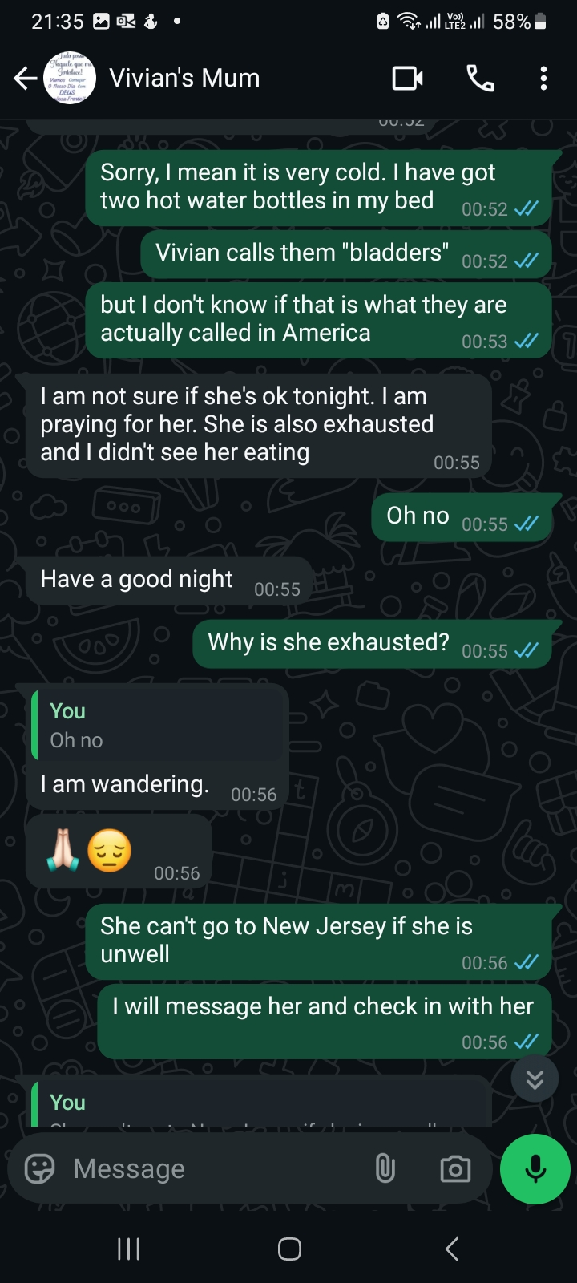
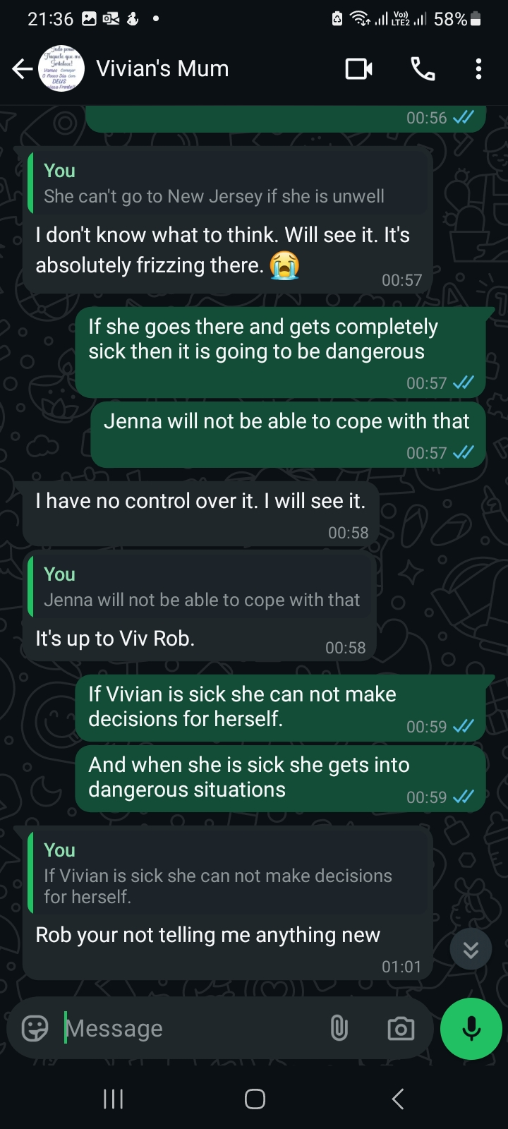
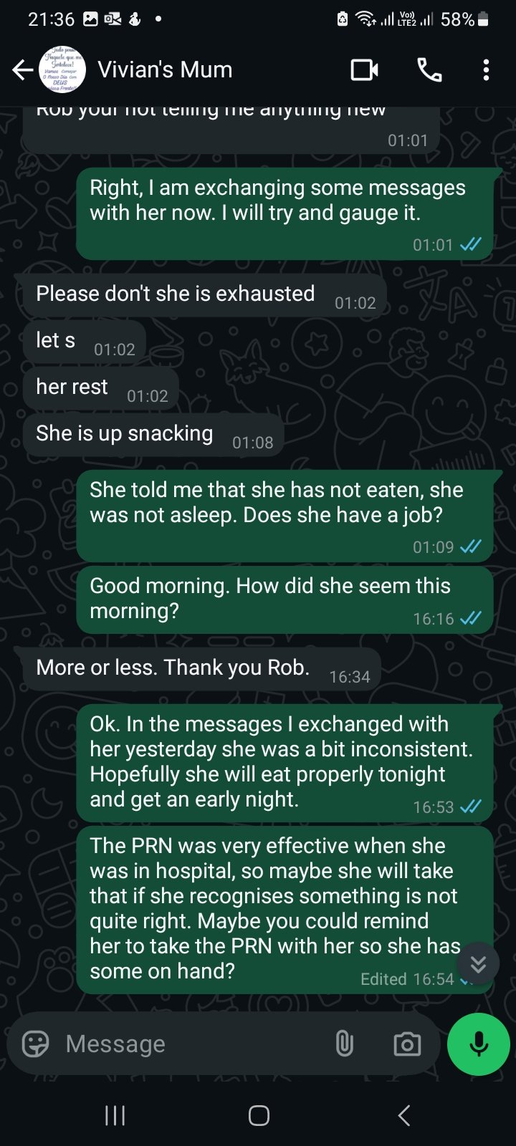
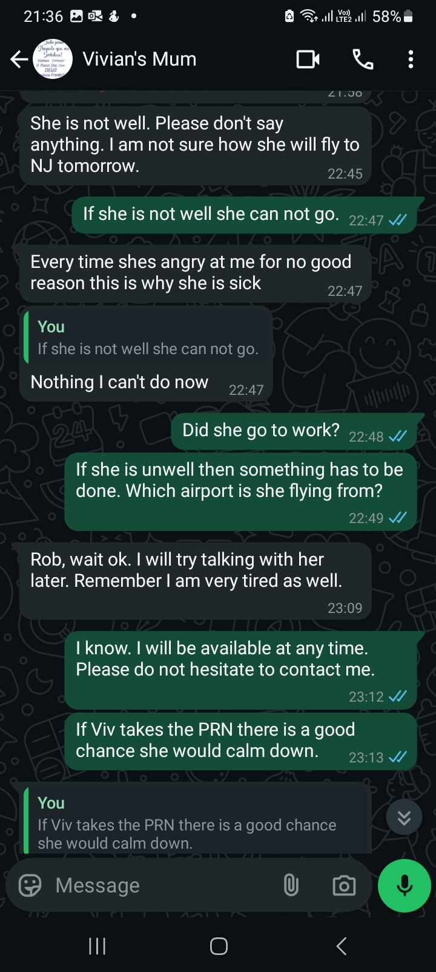
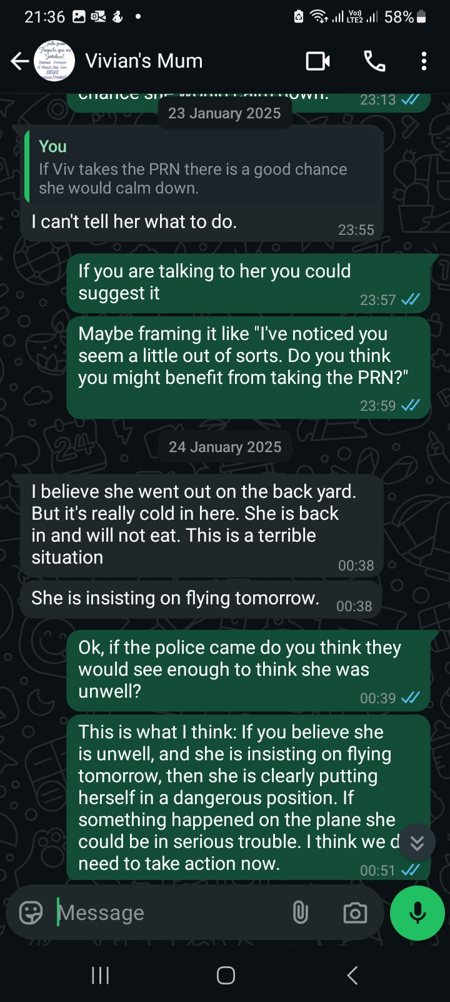
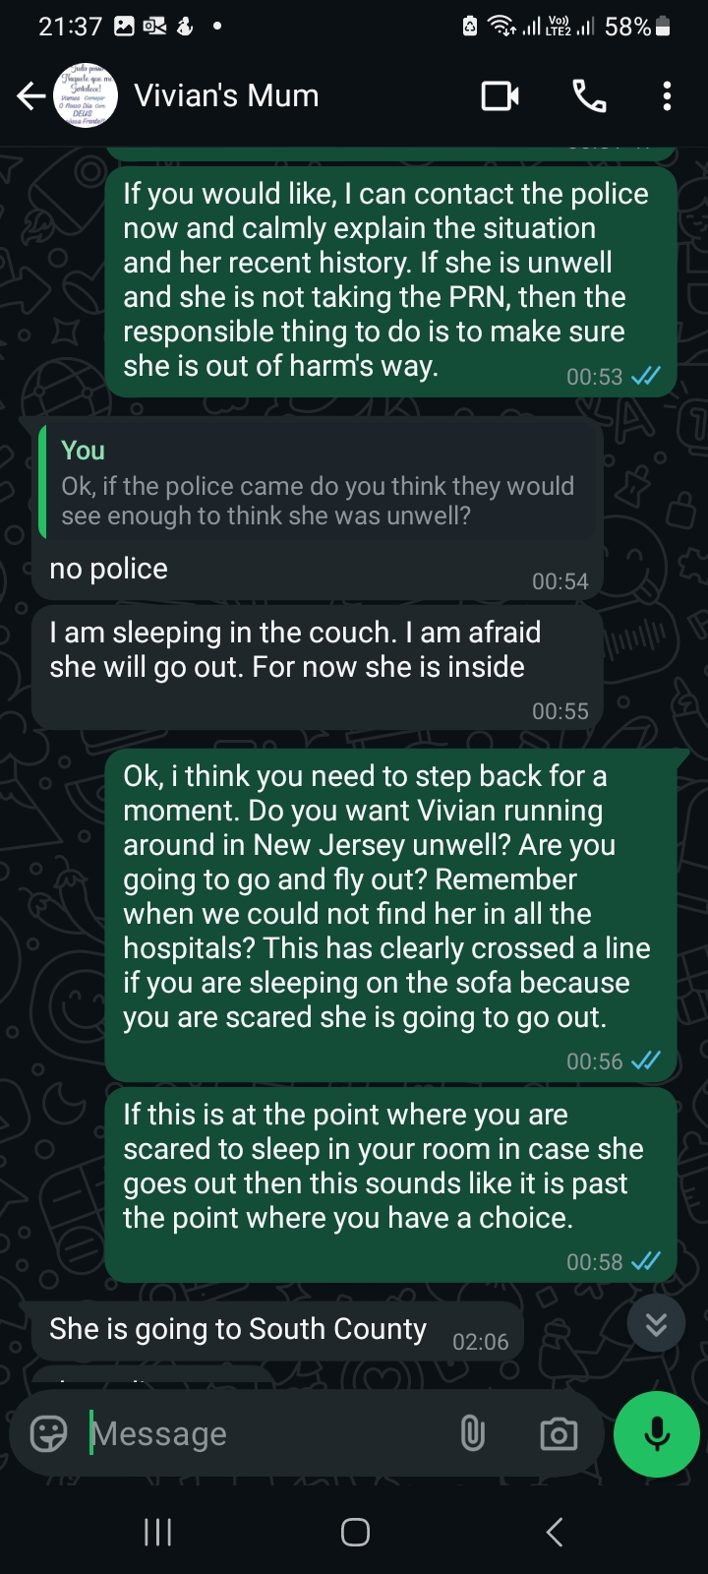

Emergency Response Triggered by Myself, Not Vivian’s Primary Carer
After receiving those message it was obvious that Mr Solange Richardson had no intention of getting help. She clearly states that she can not stop Vivian taking the flight the next day. She does not seem to care or understand that when Vivian is ill she is not in a position to make decisions for herself, and that her carer needs to intervene to get help to prevent Vivian and others coming to harm. This is clear evidence of Mrs Solange Richardson not treating psychosis like a medical emergency. I took the decision to call the police to get them to go and do a welfare check.

Acute Psychiatric Crisis Requiring Police Intervention (23 January 2025)
When they arrived Vivian had progressed to such acute psychosis that she was threatening to strangle her mother and kill all of the women on the planet, as shown in the report:

“...Solange Richardson advised her daughter WIF Vivian Richardson was not well and needed to be assessed due to her not eating and acting aggressively.

Upon arrival to the residence, Vivian who was in her room walked to the front yard to speak to me. Vivian stated "what the fuck do you want to know?" at which point I asked her how she was feeling. Vivian began acting erratically, screaming and throwing a cigarette pack which she was holding to the ground. I proceeded to ask Vivian if she felt like hurting herself or anyone else to which she replied "l feel like freaking strangling her (pointing at Solange), killing her and all the other women on the planet" while continued to scream. Vivian was handcuffed (double locked and properly spaced) and placed in the back of my BBPD patrol vehicle # 4309 to prevent her from causing any harm to herself or Officers...”

It goes on to say:

“While inside my vehicle, Vivian made additional statement stating "l wished I had a gun so I could blow some heads and see some brains splattered".”

The full police report for this incident is attached as ‘Item 1 - Police Report - Baker Acting of Vivian Richardson 23rd January 2025 – SKM_C360i25041423550.pdf’. (Please note that this report incorrectly states that Mrs Solange Richardson called for the police, but it was myself that called).

Solange denies Vivian needs to be in hospital and puts pressure on me to get Vivian released from psychiatric care as soon as possible
It is clear that Vivian was in a terrible state and making threats of a homicidal nature. It is clear that Mrs Solange Richardson recognised that she was sick, and that she witnessed Vivian threaten to strangle her and “all the other women on the planet”. However, Mrs Solange Richardson still insisted that I had called the police too early, and that in future she would refuse police entering her home. The very next day she messaged me insisting that I must try to get Vivian out of the hospital as soon as possible:

“Hi, Rob. I am going to drive to South County. I just came back home from returning the car, paid the fees, blah blah blah. And I will ask you to insist that Vivian only being held 72 hours. They screwed up her meds. She was taken a medication monthly and it worked pretty well. They change for two months. In the two months, medication injection didn't work. So she doesn't need it to stay. She's doing fine. If it wasn't for the lack or what knows what God knows about. What's going on with this medication?
So I'm gonna ask you. I'm gonna ask you to, you can try to talk to Vivian. I'm gonna try talk to Vivian today, and I'm gonna ask her wishes. Vivian should be respect.
And also I have to tell you if she does not come out in 72 hours, next time the police is here, I'm not gonna open the door, because that's her home. And if she doesn't wanna talk to the police, there is absolutely nothing I can do. So and I'm, and I'm gonna show them that I have a power of, I have a medical power of a attorney to Vivian. And if she desires not to talk to the police, she will or she will not. So I want Vivian out of the hospital soon as possible.”

The full message can be listen to at this link: https://adjustableproductions.com/apsevidence/Mrs_Solange_Richardson_threat_to_block_police_24th_January_2025.mp3

Inappropriate Pressure for Discharge During Acute Episode
It is evident from this message that Mrs. Solange Richardson either does not fully understand or does not prioritise Vivian’s clinical needs. Her focus appears to be on securing Vivian’s release from hospital at all costs, regardless of her daughter’s psychiatric state. Although she acknowledges that something may be wrong with Vivian’s medication, she frames hospitalisation as a form of punishment rather than a necessary intervention during a medical crisis. She plainly states that she believes Vivian “is doing fine,” a statement that reflects a dangerously inaccurate assessment of the situation. Rather than recognising a possible medication issue as something requiring professional oversight and inpatient care, Mrs. Richardson appears to dismiss it entirely, insisting on discharge despite Vivian still presenting with acute psychosis. Her demand that Vivian be released within 72 hours shows a concerning disregard for whether her daughter has actually stabilised. This effort to remove Vivian from critical care during a medical emergency may have directly undermined her safety and recovery.

Threat to Block Future Crisis Interventions
I would ask the service to carefully consider that while Mrs. Solange Richardson repeatedly states that Vivian’s wishes must be respected, her actions strongly suggest otherwise. In practice, she was pressuring me to persuade Vivian to leave the hospital against medical advice. More troublingly, she threatened that if I did not take steps to ensure Vivian’s release within 72 hours, she would, in future, actively prevent emergency services from intervening when Vivian was in crisis. This constitutes a deeply irresponsible and dangerous stance, particularly given the life-threatening nature of Vivian’s psychiatric condition.

Mrs. Richardson’s behaviour at this time amounted to emotional coercion. She was attempting to manipulate me into taking action that was not in Vivian’s best interest, while also asserting that she would interfere with crisis response going forward. This is something she subsequently did when Vivian became unwell again in March. I view this as a serious act of neglect.

To be clear: Mrs. Richardson spoke of respecting Vivian’s autonomy, yet simultaneously sought to shape the outcome according to her own preferences. She wanted me to influence Vivian’s decisions to align with her wishes, and made clear she intended to do the same. Despite her claims to be acting out of respect for Vivian’s choices, her conduct reveals a consistent pattern of imposing her will, particularly when Vivian is most vulnerable and in need of clarity, reassurance, and validation that her psychosis is a medical emergency, not a personal failure.

I later received the following voice message from Mrs Solange Richardson:

“Rob. I just, I just came to South County to give Vivian some warm clothes, so well here. But until you, you must understand one thing, Rob. Until I say, I say (not you), that I'm ready to call the police. I'll call the police. I'm not so sure if she really needed to come to this place. This is a horrible, horrible place to be at, Rob and I understand you mean well. I know you mean well, but sometimes you jump. Sometimes you jump guns. And I want for you to respect my decision because I am with you. Even when you were with Vivian, I would have no information. Nothing.

I just think you know what about if she would change her mind? What about if she would change her mind? I don't think that she would fly. She she has a warranty to change her flight? Not you know, so she doesn't lose the money. But I just think that you precipitate things and that's not right.
That's not right, but I understand. I'm not mad at you, but it's very hard on my body. It's very hard to come and see the situation around South County County. This is a stinky place. I don't wanna be there. I don't wanna be in to go there. I don't.

But I do understand, Rob. You just jumped the guns. I told you. No police. And you call the police anyways.”

The original audio message is at: https://adjustableproductions.com/apsevidence/Mrs_Solange_Richardson_Jump_the_gun_claim_24th_January_2025.mp3

Claiming I “Jumped the Gun” in calling the police
To reiterate at the time this message was sent, Vivian had been hospitalised under the Baker Act after threatening to kill people, including Mrs. Solange Richardson herself. Despite this, Mrs. Richardson claimed I had “jumped the gun” by contacting the police. Her remarks reveal a concerning lack of understanding about the severity of Vivian’s condition. Rather than acknowledging the need for emergency psychiatric intervention, she fixates on inconveniences such as Vivian’s flight details and the perceived unpleasantness of the hospital. Her priorities appear to centre on avoiding personal disruption, rather than on ensuring Vivian receives critical care. This attitude raises serious questions about her ability to act in Vivian’s best interests during a crisis.

Primary Carer’s Constantly Shifting Narrative
Solange’s message continued with a startling revision of her earlier statements:

“Now, I know what you I know what you say. There's no one in New Jersey for Vivian and Jenna would not know. She wouldn't. I don't know where. I know. But I just, I just think that you precipitate and you, because I'm not so sure that she would be able to function to get on the plane and go. I would not allow this to happen. I just think that it that you really jump the guns pretty quickly.”

Recording: https://adjustableproductions.com/apsevidence/Mrs_Solange_Richardson_Would_not_allow_Vivian_to_leave_24th_January_2025.mp3

This recording illustrates a recurring and troubling pattern in Mrs Solange Richardson’s behaviour: she frequently shifts her narrative to suit the moment, often contradicting her earlier statements. In this case, she asserts that she "would not allow" Vivian to board a flight. However, in the days leading up to Vivian’s hospitalisation, her messages made it clear she believed there was nothing she could do to stop Vivian from travelling, even while expressing concern about her daughter’s behaviour.
This pattern of revisionism makes it difficult to trust Mrs. Richardson’s version of events or rely on her to make consistent decisions in Vivian’s best interest. The reality, evidenced by repeated incidents, is that when Vivian is in an unwell state, she frequently attempts to leave the house, and Mrs. Richardson has been unable (or unwilling) to intervene effectively. At the time, the only appropriate and safe option was to call for professional help while Vivian remained in the home.

Contradictory Reasoning and Delayed Action in a Crisis
In a further voice message, Mrs. Solange Richardson said:
“Well, the the officer, the officer was absolutely. You know, I, I have to tell you, I was very, very concerned because, you know, not, not all the officers on, I don't know in UK, but here they they just shoot. They just shoot the person and Vivian, and Vivian, really, you know, was yelling, screaming at him on the top of her lungs
This is a very nasty, nasty neighborhood. I need to move out because I don't want Vivian to be out on the street. What she didn't she didn't take the car. She could have taken the car, but she didn't do. I think that she had the presence, presence of the mind, knowing that she wasn't well. Because how many times she she took her car and because of cigarettes. She was smoking cigarettes. So when she's smoking cigarettes there is a problem.”

Solange acknowledges extreme risk while simultaneously suggesting that Vivian was still capable of making rational decisions through “presence of mind”. This contradictory reasoning reflects a troubling pattern. Mrs. Richardson uses post-hoc rationalisations to justify her refusal to seek timely help, despite her clearly stating at the time that she believed Vivian was on the verge of leaving the house in an unstable and potentially dangerous state.
Had I not called the police, Vivian may well have driven off in a state of acute psychosis, putting herself and others in significant danger. Mrs. Richardson's hesitation to act could have led to far worse outcomes. Her reasoning shows a fundamental misunderstanding of the risks associated with severe psychiatric episodes, and a failure to prioritise Vivian’s safety when it mattered most.

Vivian’s Gratefulness for my Intervention
Mrs Solange Richardson’s failure to act during Vivian’s psychiatric crisis reflects a deeply harmful pattern of neglect. In the days following the incident, Vivian herself told me she was glad I had intervened and expressed fear about what might have happened had I not called the police. It was unmistakably clear that, even though Vivian was well beyond the point at which professional help was needed, Mrs Richardson’s intention remained to do nothing.
Mrs Richardson had already acknowledged that involving the police might carry risks, implying she recognised the severity of Vivian’s state. But rather than contacting mental health services earlier, when less invasive intervention may have been effective, she allowed the situation to escalate to the point of emergency.
This crisis was not inevitable. If Mrs Richardson had sought help when the warning signs first became clear, it’s likely that a full-scale emergency could have been avoided. Her refusal to do so, despite understanding the risks and despite prior opportunities to act, suggests either a dangerous disregard for Vivian’s condition or a desire to obstruct care. Whatever the motivation, the consequences placed Vivian, and potentially others, in serious danger. This constitutes a clearly neglecting her responsibilities as a caregiver.
Further evidence of Inertia

“I just want for you to relax 2 minutes, but I know what you're saying I would. I would not allow Vivian not allow Vivian to fly. I was speaking with her very, very calm. I know that every time she's like this, she gets angry at me and she wants to kill me, you know?”

Message recording: https://adjustableproductions.com/apsevidence/Mrs_Solange_Richardson_police_might_shoot_24th_January_2025.mp3

Mrs Solange Richardson tries to argue that I made a hasty decision to call the police and that I had needed to “relax 2 minutes.” However, I waited a full 24 hours between Solange telling me she thought Vivian was sick and me taking action. In that time Mrs Solange Richardson took no meaningful action to seek help or involve professionals, despite clear indications that Vivian was in a dangerous state of psychiatric crisis. Solange was not treating the situation like a medical emergency requiring urgent professional involvement.

What is especially alarming is the inconsistency in Mrs Richardson’s reasoning. On one hand, she stated she would not allow Vivian to travel; on the other, she dismissed immediate intervention as unnecessary, even after stating that Vivian wanted to kill her. Instead, Mrs Richardson chose to downplay the situation and criticised me for acting.
This is not consistent with responsible caregiving. The fact that she used Vivian’s threats to justify doing nothing, rather than seeking urgent care, illustrates a gross failure in judgment and a refusal to prioritise Vivian’s safety or that of those around her. Her subsequent attempts to criticise my decision to involve emergency services, despite the danger she herself acknowledged, further demonstrates a pattern of minimising risk, obstructing intervention, and gaslighting those trying to help. This constitutes clear and dangerous neglect.

Possible Motive for Obstructing Hospitalisation
Even by Mrs Solange Richardson’s standards, her actions during this period were difficult to understand. This is pure speculation, but a possible explanation only became apparent when I was served with divorce papers: Vivian had requested the necessary paperwork on 15 January 2025, a full week before Mrs Richardson first contacted me to say she believed Vivian might be unwell.
Given that I felt there were signs of illness around 17 December 2024, and the recent pattern of the prodrome phase of illness, I strongly suspect that Mrs Richardson recognised Vivian was becoming mentally unwell but encouraged her to proceed with the divorce regardless. It appears plausible that she feared if Vivian were hospitalised and then stabilised, she might once again reconcile with me, as had occurred in previous cycles of illness. This could explain Mrs Richardson’s striking resistance to seeking any form of professional help during a period when Vivian was clearly in psychiatric crisis.
This suspicion was reinforced by something Vivian said to me while in hospital and away from her mother’s influence. She told me that she had intended to proceed with the divorce that week, but had changed her mind and wanted to remain married. That brief statement suggested a return of insight once she was removed from her mother’s immediate sphere. It further strengthens the concern that Mrs Richardson was manipulating a vulnerable person suffering psychiatric instability toward irreversible legal action for her own reasons, rather than prioritising Vivian’s mental health needs. I will demonstrate later on further evidence to that makes this suspicion more plausible.

Consequences of this neglect and safeguarding concerns:
Mrs Solange Richardson’s failure to act in the face of Vivian’s clear psychiatric crisis resulted in a serious safeguarding breakdown. Despite recognising that Vivian was unwell and expressing concerns about her behaviour, Mrs Richardson refused to involve mental health professionals or emergency services. As a result, by the time I intervened by contacting law enforcement, Vivian had entered a state of acute psychosis, during which she made violent threats, including a desire to “see some brains splattered,” as documented in the police report.
Such incidents represent a clear and present risk to both Vivian and others and should be treated as medical emergencies requiring urgent intervention. Mrs Richardson’s refusal to act despite having insight into the danger posed a direct threat to Vivian’s safety and wellbeing. Her subsequent criticism of my efforts to obtain emergency care demonstrates a continued resistance to protective measures, even when Vivian's life or liberty was potentially at risk.
This pattern of inaction and obstruction constitutes a failure of duty of care and should be understood as a safeguarding violation under statutory frameworks protecting vulnerable adults. Had Mrs Richardson contacted Vivian’s care providers at South County Mental Health Center in a timely manner, early intervention may have prevented hospitalisation and associated trauma. Her failure to do so, despite knowing the severity of the situation, reflects wilful neglect and raises serious concerns about her suitability to act as a caregiver or to have any safeguarding authority over Vivian.
In light of this, I strongly urge Adult Protective Services to assess whether Mrs Solange Richardson is an appropriate person to be responsible for Vivian’s welfare and to consider any necessary protective measures, including the appointment of an independent guardian or care advocate.

Failure to act to help for Vivian when she knew she was in acute psychosis, and also actively blocking help getting to Vivian, causing Vivian to get into risky situations and trouble with the law - 3rd March 2025 to 13th March 2025

I Travelled to Florida to Oversee Vivian’s Release

Following the 23 January 2025 hospitalisation, I flew over to the US to oversee Vivian’s was release on 28 January 2025. I spent a couple of weeks there trying to support Vivian getting back on her feet. Vivian and I were getting on well, although when I left there were no plans for a lasting reunion.
During that trip I also noticed other concerning behaviour from Mrs Solange Richardson, some of which I shall document later in this report.

Agreeing a Crisis Plan with Solange
After I spoke with a social worker at South County Mental Health facility about the best courses of action to avoid Vivian having severe episodes of psychosis in the future, we came up with a plan of action for if Vivian showed signs if illness in the future. On January 29th 2025, whilst I was in the US, I made an agreement with Mrs Solange Richardson that we would contact the 24/7 Crisis Team at South County at the first sign of illness striking. We agreed that this would be the best course to avoid hospitalisations and try and minimise the impact of the illness on Vivian. As we shall see, Solange completely ignored that just a few weeks later when Vivian got sick again, with considerable consequences.

Introduction of Vivian’s brother Jonathan Richardson into Vivian’s support network
While I was in the United States, Vivian’s brother, Jonathan Richardson, and his partner, Cara Kennedy, travelled from New Jersey to visit Vivian and their mother at her home. Although Jonathan was generally aware of Vivian’s diagnosis, he had not fully grasped the severity of her condition or the seriousness of both recent and past incidents. After their visit, Jonathan, Cara, and I discussed our shared concerns regarding Vivian’s wellbeing and the highly erratic behaviour we had observed from Mrs. Solange Richardson on our visits. Jonathan expressed deep alarm at the idea of Vivian continuing to remain under their mother’s care. As a result, we formed a private Telegram group to monitor and coordinate support for Vivian. This group also included Caetlynn De Oliveira, Vivian’s paternal cousin, who had previously played an active role in her care and who is a hospital nurse with experience of psychosis admissions.

March 3 2025 - Signs of illness emerging in Vivian again:

After remaining on good terms with Vivian for about three weeks after my visit to the US, on 3rd March 2025, Vivian suddenly began sending me a series of strange messages. First she was talking about telepathy. Then she became very abusive with a much more religious tone that was notably similar to messages that I have received from Mrs Solange Richardson in the past. These messages were very out of keeping with Vivian’s normal tone in messages. These messages are attached in ‘Item 2 – Whatsapp text messages Between Vivian Richardson and Robert Wheeler - 3rd March 2025.pdf’. It looked like an obvious sign that Vivian was getting unwell and that she needed help.

With our previously agreed plan for early intervention in mind, I messaged Mrs Solange Richardson to tell her what was happening and ask her how she thought Vivian was. Solange did not reply. It transpired that she instead told Vivian I was messaging about her. Vivian then sent me a message telling me to not contact her family. Vivian continued to send me more abusive messages throughout the day.

Solange is not cooperative with efforts to get help to Vivian

While I was unfortunately not surprised by Mrs. Solange Richardson’s response, it was still a significant breach of the previously agreed-upon plan for early intervention. That plan relied on honest communication, mutual cooperation, and a shared commitment to contacting the 24/7 Crisis Team at the earliest signs of psychiatric deterioration. Instead, simply asking Mrs. Richardson whether she believed Vivian was unwell resulted in her immediately informing Vivian of my concerns in a way that appeared to escalate the situation. Rather than quietly monitoring and collaborating to support Vivian, Mrs. Richardson’s actions seemed designed to provoke distrust and further isolate Vivian from sources of support. This approach undermined efforts to secure a timely and compassionate response to Vivian’s needs.

3 March 2025 – Obstruction of the First Attempt to get the Crisis Team to Vivian

I consulted with other family members, including her brother Jonathan Richardson in the aforementioned Telegram group, and we agreed to call the crisis team anyway, which I did. Mrs Solange Richardson turned away the Crisis Team at the door on 3rd March 2025 claiming they had come too late in the evening (they arrived at 10pm). This resulted in further abusive messages and phone calls being directed to me by Vivian.

4 March 2025 – Obstruction of a Second Attempt to get the Crisis Team to Vivian

My understanding is that the crisis team attempted to visit Vivian at her home again at 7.30pm on 4 March 2025 and that Solange again turned them away at the door. It is hard to come up with a rational reason why Solange would have turned the Crisis Team away at this point. The whole point was for Vivian to be assessed by psychiatric professionals and see if there was a problem and what steps could be taken to minimise the impact of an episode of illness on Vivian via early intervention and monitoring without hospitalisation.

Crisis Team call the Police due to Solange’s obstruction
Having been turned away a second time, the Crisis Team asked the police to attend for a welfare check, and they arrived around 8pm. Vivian was judged to not need to be taken to hospital under the Baker Act. That is not surprising. The point of the Crisis Team going to do an early intervention to avoid a Baker Act and hospitalisation. Not being Baker Acted did not indicate there was no problem. The Baker Act is tool of last resort.

Solange Tells the Police Efforts to get Help to Vivian are “Harassment”

The initial evidence I had of this welfare check was the police report. That was damning enough. However, late in compiling this report I received body worn camera footage from the event. I believe this is an absolutely critical piece of evidence. Right from the beginning Solange dismisses Vivian’s father’s role in Vivians life. Solange continually minimizes Vivian’s illness. Solange even cites me calling the police on 23rd January as evidence of me abusing Vivian, even though Vivian was obviously in psychosis. When Vivian comes out she complaining talking about my past efforts to try and get her help, and Solange is affirming these things as abuse. Solange is constantly gatekeeping the conversation and misleading the police. Not once does Solange mention Vivian’s prior hospitalisations. She actually steers Vivian away from talking about it. Both Solange and Vivian are talking about me trying to contact Vivian all of the time, as if I had been hassling her. The reality was that we were maintaining communication. I was being very careful about not agitating Vivian. Vivian had been abusive towards me and giving unwanted attention. Vivian’s perception is clearly warped as she is describing me

According to the police report from the welfare check on 4 March 2025, when officers questioned Mrs. Solange Richardson about the circumstances leading to the call, she alleged that I was attempting to "harass" Vivian from abroad due to a pending divorce. However, at the time of this welfare check, no divorce proceedings had been initiated and I had not been served with any papers. The reference to divorce was therefore not only factually incorrect, but it also appears to have been a deliberate attempt to shape a narrative that discredits my safeguarding concerns. This raises the possibility that Mrs. Richardson was both misrepresenting the situation to law enforcement and placing pressure on Vivian to proceed with divorce filings as part of her broader effort to isolate her from protective interventions.
Mrs. Richardson’s further comment to the police that my efforts to get help for Vivian represented an "ongoing problem", is deeply concerning. It suggests that she continued to view appropriate safeguarding interventions, including Vivian’s previous hospitalisation under the Baker Act in January 2025, as unwarranted. This position reflects a dangerous and persistent denial of Vivian’s psychiatric condition and a failure to treat episodes of psychosis as medical emergencies. By framing previous critical interventions as problematic, Mrs. Richardson appears to be reinforcing a narrative that deters external help and isolates Vivian from sources of support. This undermines Vivian’s access to timely and necessary treatment, and should be considered a recurring safeguarding risk, particularly given the documented pattern of delayed or blocked interventions leading to escalated crises.

From a safeguarding perspective, such deliberate misrepresentation poses serious risks. It creates a chilling effect on concerned parties who may otherwise intervene in good faith. It may also prevent timely assessments, prolong psychotic episodes, increase the risk of harm to Vivian and others, and hinder coordination between law enforcement, crisis teams, and medical providers.

This incident underscores a broader pattern of behaviour by Mrs. Richardson, in which valid attempts to secure psychiatric care are reframed as personal interference. This is not only factually incorrect, it represents a failure to prioritise the safety and well-being of a vulnerable adult in medical crisis.
Police documentation of this incident is included as Item 3 – Police Report from Welfare Check on Vivian Richardson, 4 March 2025 (SKM_C360i25050104360.pdf).
.

Escalating Rejection of Support from Family Members

I understand that Vivian’s brother Jonathan Richardson directly contacted Mrs. Solange Richardson to urge her to seek immediate help for Vivian, reinforcing that I was acting in Vivian’s best interest. Rather than responding constructively, Mrs. Richardson reportedly dismissed these concerns and referred to me as “the enemy.” In the context of Vivian’s and Solange’s increasingly religious framing of events, I interpret this to mean “the enemy of God”, a disturbing indication that her judgment was being guided by ideological or delusional thinking rather than Vivian’s welfare. This further isolates Vivian from effective support and places her at continued risk.

Undermining Crisis Response: Blocking Vivian from Accessing Law Enforcement Support

By 8 March 2025, I understand that Vivian was exhibiting clear signs of acute paranoia. She reportedly believed that a colleague she had voluntarily agreed to meet had followed her home, which led her to express a desire to contact the police. Rather than supporting Vivian in accessing appropriate support during this moment of distress, Mrs Solange Richardson allegedly dissuaded her from contacting law enforcement. This intervention raises serious safeguarding concerns. If Vivian were indeed well and acting rationally, there would be no clear justification for preventing her from seeking help from the authorities. However, if Vivian was not well (as her paranoia suggests) then blocking her access to crisis intervention reflects a failure to protect her from further psychological distress and potential danger. The implication is that Mrs Richardson may have been more concerned about avoiding another Baker Act intervention than addressing Vivian’s immediate mental health needs, thereby placing Vivian at continued risk.

12 March 2025 - Solange’s Delayed Attempt to Get Vivian Assessed for a Baker Act
Compromised Crisis Response Due to Undermined Credibility

By 12 March 2025, Vivian’s situation was dire. Vivian received multiple citations that afternoon for extremely dangerous driving. I was made aware that she had then posted video evidence on Instagram of herself burning those citations and a post saying “hail Satan”. This strongly indicated that she was driving dangerously and in acute psychosis.

I contacted law enforcement to request a welfare check, only to be informed that officers were already at the property. The police report indicates that Mrs Solange Richardson had already called for help, signifying that even she now acknowledged the seriousness of Vivian’s condition. When officers arrived, Vivian was reportedly outside, engaging in disruptive behaviour by loudly playing her violin despite being a beginner. This, combined with her earlier actions, presented clear indications of disorganisation and emotional instability, which typically warrant an assessment under the Baker Act.
However, the situation was critically undermined by previous false and defamatory statements made by Mrs Richardson. Vivian reportedly repeated the false claims that I was harassing her due to a supposed divorce. As a result, my call, which should have added weight to the need for psychiatric assessment, was misconstrued as part of a fabricated personal conflict.
Ultimately, the officers concluded that Vivian was “in great shape” and left without initiating the Baker Act, despite significant red flags. This outcome reflects a major safeguarding failure. Prior false narratives, introduced by Mrs Richardson, had eroded the credibility of family-led concerns and directly obstructed appropriate crisis intervention. Tragically, this occurred just as Mrs Solange Richardson herself was beginning to seek help for Vivian, demonstrating how earlier neglectful actions can have long-lasting and compounding effects on a vulnerable adult’s access to protection and care.
I have included the police report for this visit.

Attempt for Crisis Team to reach Vivian at work
On 13 March 2025, following persistent concerns for Vivian’s safety and well-being, I contacted the Crisis Team once again to try to coordinate an intervention at her workplace. This decision was made specifically to bypass ongoing obstruction from Mrs Solange Richardson, whose gatekeeping had repeatedly prevented earlier outreach attempts.
However, before they could get there, Vivian called from work in a state of total psychosis, belching and swearing loudly in front of her colleagues. I believe this contributed to her being dismissed from her job that morning.

Another failed Police Baker Act intervention (with recorded evidence)
Due to an earlier misunderstanding when I had called the police, law enforcement arrived at Vivian’s home before the Crisis Team could reach her. During their assessment, Vivian called me and remained on the line while speaking with the officer. I recorded the call from the UK, where single-party consent is legally permissible. The audio has been included as supplementary evidence to demonstrate how, even in a state of florid psychosis, Vivian could present as superficially composed during official assessments.
Recording link:
https://adjustableproductions.com/apsevidence/Vivian_Richardson_Police_Assessing_for_Baker_Act_13_March_2025.mp3

Successfully Baker Acting in another police jurisdiction
Later that same day, Vivian phoned me again, this time from outside the jurisdiction of the initial responders. She had travelled to Bethesda Church in Palm Beach. I kept Vivian on the line whilst I coordinated with Cara Kennedy, who alerted the Palm Beach police. Officers were able to locate Vivian as she was leaving the church and finally enacted a Baker Act intervention.

Vivian makes homicidal threats again
Upon her arrival at JFK North Hospital, police noted that Vivian made explicit threats to harm hospital staff. I understand that body-worn camera footage from this incident also shows Vivian physically attacking nursing personnel shortly after arrival.
This chain of events underscores the seriousness of Vivian’s psychiatric decline and the real risk she posed to herself and others at this stage. It further highlights the critical importance of timely intervention, and the role that previous delays and obstructions played in allowing her condition to reach this dangerous level.

Consequences of Delayed Intervention and Ongoing Obstruction

Between 3 and 13 March 2025, Vivian’s condition escalated into a state of acute psychosis, during which she experienced significant deterioration in her functioning and posed substantial risks to both herself and the public. During this period, she was involved in multiple incidents of dangerous driving that resulted in legal consequences, including a criminal case and mandated community service. Concurrently, she lost her job after displaying severely disorganised and alarming behaviour at her workplace.

Vivian also incurred significant financial harm, including out-of-network hospitalisation costs, legal fees, and loss of earnings, none of which would likely have occurred had early intervention been permitted.

This sequence of events represents a serious safeguarding breakdown. At multiple critical junctures where early intervention could have de-escalated Vivian’s psychiatric crisis, Mrs. Solange Richardson actively obstructed or undermined the efforts of other concerned family members. This was not an isolated misunderstanding nor an instance of overreaction. Even when her son, Jonathan Richardson, explicitly urged her to take action, she refused.
In response, two other adults, myself and Cara Kennedy, had to coordinate alternative emergency pathways to bypass the instability and obstruction created by Mrs Solange Richardson. As a result of the delayed intervention, Vivian was exposed to avoidable legal consequences, financial penalties, psychological trauma, and significant risk of physical harm to herself and others.
Given the pattern of repeated interference with medical professionals, dismissal of observable psychiatric symptoms, and refusal to collaborate with family-led safeguarding attempts, this case raises substantial concerns of neglect and obstruction of care. It merits urgent review by Adult Protective Services under statutory duties to protect vulnerable adults from foreseeable harm and systemic failure in caregiving environments.

I have included the police report as ‘Item 4 - Police report - Baker Act 13th - March 2025 – 25-477_-_Incident_Report_-_Redacted.pdf’. I have also included the police reports for the six driving citations she received in this time as Items 6 through to 10. I have included the Court Event form for this incidents as Item 11, and the Pre-Trial Agreement as Item 12.

Failure to Recognize Duty of Care and Disengagement from Support Role
Mrs. Solange Richardson later sent a voice message responding to criticism from her son, Jonathan Richardson, in which she objected to his assertion that she had “done nothing” to help Vivian. In that message, she stated:
“Now to say that I didn't do anything, it is a lie, because there's so much I can do after she's 18. She is entitled to do whatever she wants.”

This statement illustrates a fundamental misunderstanding of the responsibilities involved in caring for a vulnerable adult with a serious mental health condition. Rather than acknowledging Vivian’s loss of executive function and capacity during acute episodes, Mrs. Richardson framed her lack of action as a function of Vivian’s legal adulthood, failing to consider her daughter’s impaired judgment during psychiatric crisis. This rationale effectively denies the presence of any medical emergency and constitutes a refusal to recognize her continuing safeguarding duties as a de facto caregiver.

More concerning is that Mrs. Richardson not only failed to intervene, but also actively undermined efforts by others to seek help for Vivian. As documented in official police reports, she described those attempts as “harassment,” a characterization that may have contributed to delays in crisis intervention and the failure of law enforcement and medical services to respond appropriately.

“And if she has a problem as we speak it means that she picked the K2 to smoke, not me. I didn’t put a gun on her head and told her “look, go out with the parents and go out with your friends and go smoke K2.” She did it herself. I'm washing my hands. I'm gonna move way far away from Palm Beach City, from Palm Beach County, and I don't wanna hear anymore.”

This reference to events that occurred approximately 15 years earlier, when Vivian was still a teenager, raises significant concern. It appears that Mrs. Richardson is using past adolescent behavior to justify her present-day disengagement from a crisis situation involving an adult daughter with a known psychiatric disability. Her statement, “I’m washing my hands,” strongly suggests an intentional abandonment of the duty of care.
This position is especially troubling in light of the fact that Mrs. Richardson previously urged Vivian to return to the United States from the UK, despite warnings that Vivian was experiencing significant psychiatric instability. In doing so, she assumed a caregiving role and voided Vivian’s UK visa leaving no way back to her former living arrangements. The failure to uphold even basic safeguarding responsibilities after requesting that Vivian return indicates a pattern of neglect that has had serious consequences for Vivian’s health and safety.
The audio excerpt of Mrs. Richardson’s statement is available at:
https://adjustableproductions.com/apsevidence/Mrs_Solange_Richardson_20th_March_2025_message_excerpt.mp3

Coercive Interference by Mrs. Solange Richardson in Vivian’s Attempt to Access Mental Health Rehabilitation – 19 March 2025

During Vivian’s hospital stay in March 2025, Vivian reconciled with me again. Given the instability in our relationship and the importance of bringing others into Vivian’s care planning, I encouraged Vivian to embrace the support of her brother Jonathan Richardson. He was enthusiastic about new potential treatment pathways. Whilst she was in hospital Vivian and Jonathan made arrangements for her to attend a four-to-six-week residential mental health rehabilitation programme at the Clinical Wellness Center in Lantana. The objective was to help Vivian break the cycle of repeated psychiatric crises through structured therapeutic support in a neutral environment. Given Mrs. Solange Richardson’s recent history of obstructing Vivian’s access to care, this plan was not initially shared with her to avoid interference.

Upon discovering Vivian’s intention to leave for rehabilitation, Mrs. Richardson reportedly reacted with significant verbal aggression. As Vivian prepared to depart, she messaged that her mother was "flipping out" and had told her she would be “raped and killed” at the facility (see WhatsApp screenshot below):
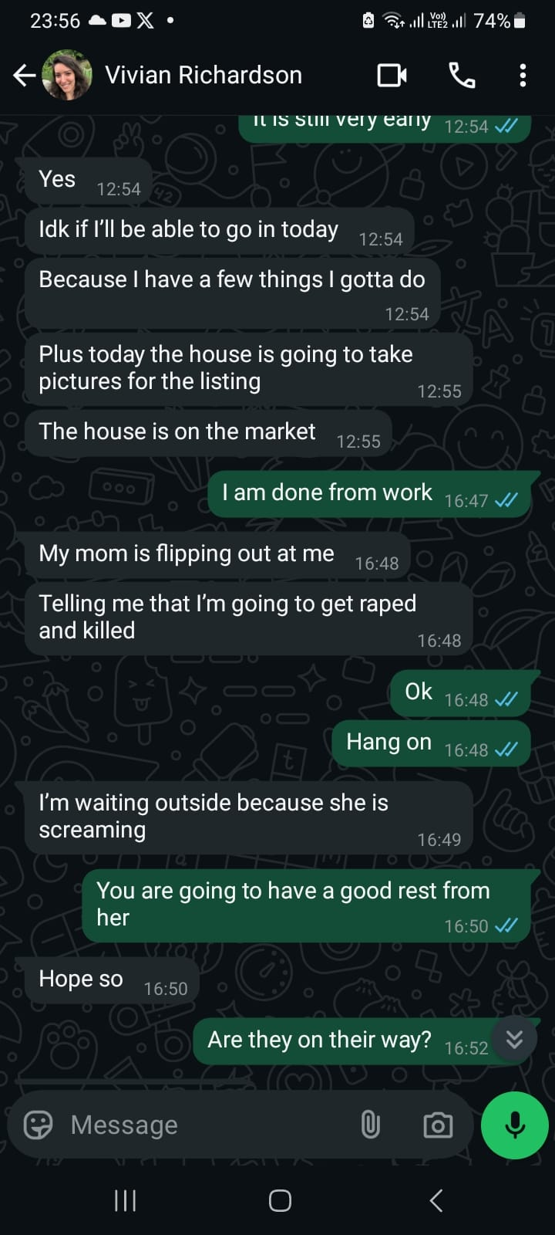

This alleged statement, if accurately reported, represents a serious safeguarding concern. Threatening a vulnerable adult with extreme outcomes in order to deter them from accessing voluntary mental health treatment is a form of psychological coercion. Moreover, this is particularly distressing given prior disclosures by Mrs. Richardson herself that Vivian may have experienced sexual trauma in adolescence. Leveraging such a history, real or perceived, to manipulate Vivian’s decision-making is not only emotionally abusive but also demonstrates a continued pattern of obstructing her access to appropriate care.

Coercive Behaviour and Threats of Eviction in Response to Mental Health Treatment

Mrs. Solange Richardson also issued threats that she would evict Vivian from her home as a consequence of attending the program. This conduct demonstrates coercive and controlling behaviour and represents a serious safeguarding concern, particularly given Vivian’s vulnerable mental health status and historical pattern of housing instability.
This behaviour appears consistent with past actions, as Mrs. Richardson has previously made Vivian homeless. These threats coincided with messages in which she indicated she would implicate or report others myself and rejected her son Jonathan Richardson, for allegedly facilitating Vivian’s entry into care. In a voice message sent during this period, Mrs. Richardson stated:
“So, when I told Vivian to wait, I had a absolutely a reason to do. I never told her, “Look, don't go”, I said “Wait for one day.”
I'm not going to get involved any longer. She will pack her stuff and she will go with Jonathan. And you are behind this as well. But from you I expect anything and everything. Because you had no business in my house. You had no business in my family on the very first day and I received you and I treat you like a king when you're not.
You are a old man with no job. You have no prospect and your problem. You're jealous of my daughter. You're jealous of Vivian. You're jealous because you're never gonna be her in a million years. And doesn't work. He doesn't lie to you, I understand. What Vivian did, but you don't believe because you need treatment yourself. So this is it. If something happens with her, I'm going to implicate you. I'm going to implicate I'm going to report what you did. I'm gonna show the police report. We already have on you, and I'm gonna show the police and make sure you have your share of what you threw Vivian into.
Now this lunatic called Jonathan Richardson. He's not my son. He's out of my banking account. He's out of my will because he's unfairly spoke about something he never knew. He was never involved. One single day of Vivian care, and by the way, he didn't care as well. Because he smoked pot himself.
All he did was drinking. Use my name. Use my my car insurance so I couldn't have, you know, and and my his car was under my name because he doesn't even have a good credit. Why? Because he chose like Vivian the bad way. Smoking pot. Smoking cigarettes, drinking and that is my crime.”

For your reference, this is the original recording:
http://adjustableproductions.com/apsevidence/Mrs_Solange_Richardson_Police_threat.mp3

The tone and content of this message raise red flags from both a safeguarding and legal standpoint. The message contains multiple personal attacks, false characterizations, and implicit threats against family members who were attempting to ensure Vivian’s access to medical care. Mrs. Richardson appears to equate Vivian’s voluntary participation in a rehabilitation program with being harmed or thrown in something by others suggesting a deeply distorted understanding of her daughter’s mental health needs.
Additionally, Mrs. Richardson’s claim that she merely asked Vivian to “wait one day” before entering the program stands in direct contradiction to previous recorded statements, where she instead used explicitly threatening language (including implying that Vivian would be raped or killed if she entered treatment). This misrepresentation, combined with threats of retaliation, may reflect a pattern of psychological manipulation and obstruction of care.
She also directs similar abuse toward her son, Jonathan Richardson, declaring he is “no longer [her] son,” removing him from her will, and attacking his character and past behaviour. These statements suggest a hostile family environment in which supportive relatives are punished or vilified for attempting to intervene appropriately.
Given Vivian’s psychiatric vulnerability, the use of coercive tactics and threats of homelessness to influence or punish her for seeking care could be construed as a form of psychological abuse. These behaviours should be thoroughly investigated under the principles of adult safeguarding and may constitute grounds for protective intervention under APS protocols.

Malicious Allegations and Their Impact on a Vulnerable Adult's Safety

In addition to the safeguarding implications already outlined, Mrs. Solange Richardson’s message includes several personal attacks and demonstrably false claims about my employment status and motives. She states that I am unemployed, despite knowing that I have been in continuous professional employment since February 2020. She also accuses me of being jealous of my wife, Vivian, a claim that appears wholly ungrounded and delusional. This type of projection raises serious concerns about the narrative she may be feeding to Vivian, who is already experiencing delusions and heightened paranoia during periods of illness. In such a vulnerable mental state, even subtle suggestions from a primary caregiver can significantly distort Vivian’s perception of who is trustworthy and who is not. Given that I have consistently acted in Vivian’s best interests, including during crises when her safety was in question, this attempt to discredit me not only undermines my ability to support her but also places her at further risk by isolating her from those committed to her welfare. Mrs. Richardson’s claims about past police reports are also vague and unsubstantiated, further contributing to a climate of confusion, fear, and misplaced suspicion around Vivian. Her continued framing of psychiatric care as punishment rather than support suggests a fundamental unwillingness to recognise Vivian’s diagnosis and needs compounding the risk of future harm.

Wider Pattern of Emotional Abuse and Isolation of Support Figures

This pattern of abusive and erratic communication from Mrs Solange Richardson was not limited to myself. I understand that Vivian’s brother, Jonathan Richardson, was also subjected to similarly hostile and aggressive messages during this period. He ultimately felt compelled to block contact with his mother in order to protect his own mental wellbeing. This is significant from a safeguarding perspective, as it suggests a broader pattern of behaviour in which Mrs Richardson alienates and verbally attacks those attempting to advocate for Vivian's safety and welfare.

Such behaviour undermines the integrity of Vivian’s informal support system and leaves her increasingly isolated, reliant on a caregiver who has demonstrated repeated resistance to professional intervention and has actively obstructed mental health services. This should be of concern to APS, as it may indicate ongoing emotional abuse not only directed at Vivian but also weaponised against those who attempt to intervene on her behalf. This obstructive dynamic is a common feature in cases of coercive control and gatekeeping abuse, and should be considered in the context of assessing both risk and capacity for safe caregiving within Vivian’s current environment.

Further Observations over Coercive Control Dynamic and Housing Destabilisation

A particularly troubling dynamic arises when Vivian demonstrates moments of lucidity and actively seeks treatment. Rather than supporting these efforts, Mrs Solange Richardson has responded by threatening to withdraw housing and support unless care proceeds strictly on her terms. This includes direct threats to make Vivian homeless as retaliation for choosing to enter a rehabilitation facility, a decision that had been discussed and agreed upon by Vivian and her brother Jonathan Richardson. Mrs Richardson’s threats appear to be triggered not by concerns over the quality of care, but by a perceived loss of control over Vivian’s decision-making.

This stands in stark contrast to Mrs Richardson’s earlier claims that she could not intervene when Vivian was in psychosis “because she is over 18 and can do what she wants.” When Vivian is severely unwell, Mrs Richardson portrays herself as powerless and uninvolved. Yet, when Vivian is making rational and collaborative decisions about her own care, Mrs Richardson attempts to reassert dominance, even to the point of criminalising those who assist. This contradictory stance strongly suggests an inappropriate use of leverage to maintain control, which has direct implications for safeguarding.

Mrs Richardson has also projected blame onto others, particularly myself, accusing me of manipulation or criminal wrongdoing simply for supporting Vivian in a plan agreed with her brother. Despite frequently claiming I have undue influence over Vivian, she simultaneously attempts to compel me to act in alignment with her own demands, even when doing so would be against Vivian’s best interests. This speaks to a pattern of emotional triangulation, in which Mrs Richardson seeks to use others as instruments of coercion.

Further compounding the concern, Mrs Richardson’s statements about her son Jonathan are demonstrably false. She has spoken about him in highly disparaging and historically inaccurate terms, referring to him as irresponsible and financially unstable, despite his stable employment and recent qualification for a home builder’s loan. These statements appear to be attempts to discredit anyone within the family who challenges her authority or supports Vivian’s independent choices.

Taken together, these behaviours raise serious concerns about Mrs Richardson’s fitness to act as a primary caregiver, and whether she may be engaging in emotional abuse and control masked as caregiving. APS should consider whether her behaviour is serving Vivian’s best interests, or whether it is contributing to the perpetuation of psychiatric instability, dependency, and isolation.

Concerns Regarding Carer Insight, Mental Health, and Impact on Dependent Adult

There is increasing concern that Mrs Solange Richardson may lack the psychological insight required to safely serve as a carer for a vulnerable adult. Her repeated inability to distinguish between her own actions and those of others suggests a potential pattern of projective blame, wherein she externalizes responsibility for her own decisions while condemning others—often aggressively—for perceived infractions. This behavior has been consistent across multiple incidents, including those in which she acted obstructively toward medical professionals, rejected early intervention strategies, and mischaracterized others’ involvement in Vivian’s care as "harassment."

This rigid denial of her own role in crisis escalation, combined with a tendency to invert blame onto others, may point to underlying cognitive or emotional impairments that merit further assessment. It also raises questions about whether her actions are the result of unmanaged mental health issues that could compromise her decision-making capacity and pose risks to those under her care.

Of particular concern is the possibility that Mrs Richardson may be intentionally preserving Vivian’s dependency and instability as a means of maintaining control. When Vivian is unwell, Mrs Richardson describes herself as powerless to act due to Vivian's legal adulthood. Yet, when Vivian shows initiative or seeks care, Mrs Richardson attempts to reassert authority—often through punitive or manipulative tactics, including threats of homelessness or false allegations against supportive family members.

This constellation of behaviors—denial, blame displacement, contradictory justifications, and punitive control—presents a safeguarding red flag. APS should consider whether Mrs Richardson’s continued involvement is in Vivian’s best interests, or whether her conduct is contributing to cycles of instability, obstructed care, and emotional harm.

Consequences of this neglect:

Consequences of Disrupted Treatment and Coerced Compliance

Following extensive family coordination, Vivian made a significant and autonomous decision to attend a residential mental health treatment program an important milestone indicating insight into her condition and a willingness to pursue lasting therapeutic support. However, soon after she arrived, she called both Jonathan and myself saying that she was considering leaving. I spoke with one of Vivian’s clinicians who felt that Vivian stood to get great benefits from attending. The next day I had a long conversation with Vivian, which concluded with her asking me to contact her mother to to let her know that she wanted to apologise for attending the treatment and that she wanted to come home. This is profoundly troubling. The decision to enter rehabilitation should be met with support, not coercion or guilt. Instead, Mrs Solange Richardson created a hostile emotional climate that actively discouraged Vivian from remaining in the facility and engaging in much-needed care.
This moment represented a rare and time-sensitive opportunity for Vivian to receive intensive, trauma-informed therapy and diagnostic evaluation, including exploration of potential repressed trauma. Such opportunities are often limited and must align with both clinical availability and patient readiness. The intervention Vivian agreed to was designed to address root causes of illness, not merely manage symptoms through medication. The psychological and emotional damage caused by being pressured to abandon this care may reverberate for years to come.

Lithium Use Agreed Under Questionable Circumstances
In the wake of this disruption, Vivian reportedly consented to begin lithium treatment, not as a proactive medical choice, but seemingly as a strategic measure to support her legal defence in an ongoing criminal case stemming from dangerous driving during a previous psychotic episode. Notably, Vivian had previously expressed clear reluctance to take lithium due to concerns about its long-term impact on her kidney health. This sudden reversal raises serious safeguarding concerns. The decision appears to have been made not from a position of informed medical empowerment, but under emotional duress and external coercion, particularly following the destabilising and guilt-inducing pressure exerted by her mother. In such a context, it is doubtful whether true informed consent was possible. This raises ethical and legal concerns about medication compliance under duress, especially for a vulnerable adult whose autonomy may have been compromised.
Lithium can be an effective stabiliser, but it is also known for its blunting effects on cognition and emotional processing, as well as potential long-term renal toxicity. By forcing Vivian into a medication-only pathway, her chance to engage in meaningful psychotherapy may now be reduced, delaying recovery and perpetuating dependency. Moreover, there is a serious risk that her current treatment trajectory is more reflective of her mother’s preferences than of her own needs or clinical best practice.
This case represents not only a lost window for deep psychiatric intervention, but also highlights an emerging pattern of treatment sabotage and emotional coercion by Mrs Richardson, with long-term safeguarding implications. Vivian’s autonomy was undermined at a moment of vulnerability, and her current treatment may mask symptoms without resolving underlying causes. APS should consider whether Vivian’s current living and caregiving arrangements continue to pose barriers to recovery, reinforce dependency, and expose her to ongoing emotional manipulation.

Additional Indicators of Risk and Carer Impairment
Several further incidents involving Mrs Solange Richardson raise serious questions about her capacity to prioritise Vivian’s welfare. These behaviours suggest either a pattern of placing her own preferences above Vivian’s best interests, repeated lapses in judgement resulting in harm, or a potential deterioration in Mrs Richardson’s own mental functioning. Each scenario represents a significant risk factor for neglect and may warrant further assessment of her suitability to continue in a caregiving role.

Coercive Interference with Immigration Status and Delusional Justifications for Medical Noncompliance During Vivian’s August 2024 Hospitalisation
During Vivian’s first hospitalisation in the UK in August 2024, Mrs Solange Richardson persistently denied the reality and severity of her daughter’s psychiatric condition. Despite professional medical care being in place, Mrs Richardson demanded access to Vivian’s doctors and insisted that I immediately place Vivian on a plane back to the United States. These demands were not only medically inappropriate but legally unfeasible, as Vivian had, during her illness, cancelled her UK Spousal Visa and instead filed for a Domestic Abuse Visa a process that legally restricted her from leaving the country for six months. Vivian was also still estranged from her mother at this point.
Mrs Richardson disregarded these legal constraints entirely, claiming that such immigration rules were irrelevant and asserting, incorrectly, that Vivian could simply re-enter the UK without consequence. This represents a concerning pattern of behaviour in which Mrs Richardson overrides expert and legal guidance in favour of her own views, placing Vivian at significant risk of legal complications, destabilisation, and loss of access to healthcare.
Of even greater concern were the delusional and coercive elements of Mrs Richardson’s communications during this period. She claimed that God had given cancer to both Vivian’s father Daniel Richardson and maternal uncle Romulo Barreto as divine punishment for disobeying her wishes. Solange explicitly threatened that I would suffer the same fate if I did not comply with her demand to remove Vivian from care and return her to the U.S. This is not only emotionally abusive, but suggests a potential religious delusion or fixation that impairs Mrs Richardson’s ability to act in her daughter’s best interest.
For APS reference, a full audio recording of this statement can be accessed here:
http://adjustableproductions.com/apsevidence/Mrs_Solange_Richardson_God_Cancer_Threat.mp3

I reproduce the full transcription here:

“Well, we… Rob, you tell me that my daughter is delusional because she doesn't like your mother. Is this makes any sense? It, look, I'm not a stupid Rob. I never wanted you to marry her. Never, because I knew that she was not ready. She was not ready. So this thing, this whole thing is not going well.
I am not the stupid father because he's a stupid instead of take care of the daughter, he goes out and drinks with you every night. And this is not what a Christian dad would do. He would be with somebody else, OK, watching both of you. Not that he hates you.

I don't have to hate you, but I don't like what you doing, and someone someone in the UK will listen to me. I don't know how. And also you're not fighting me, you're fighting God.
Be careful. Be careful. Because all the enemies of God doesn't end well. My brother didn't end well.
He has cancer now. Nobody in my family has cancer. Do you know why? Because he fought God.
He took Vivian from my hands and he put he end up putting my daughter in the New York hospital that she has $30,000. It was because of him. And now he's dying of cancer.

The father was nasty, took Vivian from my hands. And now he has a bunch of tumors.
Be careful. Be careful. Do the right thing. I, I urge you. I urge you, if you like your life, if you honor your mother (because your father is no longer here). Be careful. Put my daughter into the plane and return her to the USA. She needs someone to bring her back home and I am going to do just that.”

Mrs Solange Richardson’s messages contains a series of unfounded and accusatory statements. Vivian’s father, Daniel Richardson, travelled to the UK in late August 2024 to assist during a serious mental health crisis, despite his own impending treatment for skin and throat tumours. Mrs Richardson remained in Florida, prioritising care for her dogs over being physically present to support her daughter. She criticises both Daniel and myself for briefly going to a pub for dinner after stressful hospital visits. For the record, I do not drink alcohol and did not consume any during these occasions.

Concerns About Delusional Thinking and Caregiver Fitness
There is credible reason to believe that Mrs Solange Richardson genuinely believed in a grandiose religious delusion, that both Daniel Richardson and Vivian’s maternal uncle, Romulo Barreto, were afflicted with cancer as divine punishment for disobeying her. This type of cognitive distortion and externalised blame, particularly in the context of caregiving for a severely mentally ill adult, should not be overlooked. Multiple family members have expressed concern about Mrs Richardson’s grasp on reality and the psychological fitness required to be a safe and reliable caregiver. These behaviours warrant serious review by Adult Protective Services to determine whether continued unsupervised responsibility over Vivian is appropriate or sustainable.

Second UK hospitalisation September 2024:

Circumstances of second hospitalisation:
On 13th September 2024, Vivian experienced a second psychiatric crisis in the UK. Emergency services were called after she removed her clothes in public and displayed sexually inappropriate behaviour toward her landlord. She was subsequently detained under the Mental Health Act and transported to Highbury Hospital for assessment. Following assessment Vivian was sectioned for 28 days, back to Sherwood Oaks Hospital. These events occurred entirely independently of my presence; my only role was to confirm with the landlord that he had called an ambulance and to later alert responders that Vivian might become agitated, which led to the police being involved.

Solange’s Further Fabricated Claims and Denial of Clinical Reality
Despite these facts, Mrs Solange Richardson, speaking from Florida, accused me of orchestrating Vivian’s hospitalisation to control her. She rejected any suggestion that Vivian was unwell and instead fabricated a false narrative. This included a baseless claim that Vivian’s cousin, Andrey Conte, had accused me of abuse and food deprivation. When I contacted Andrey directly, he denied making these claims and confirmed he had not spoken to Mrs Richardson in years. In fact, Andrey had attempted to assist Vivian by arranging a meeting with the crisis team the day prior to her admission, a meeting Vivian missed due to her deteriorating condition.
This is the message she sent me:

“Rob, how look, how can I verify that all this is truth? I don't know. You are preventing me from talking to any doctor. You are preventing me from seeing Vivian, and I have nothing else on my hand. Rob, if this doesn't go through, I have to, I already decided to talk to someone on the American embassy, because you won't give up. Because you won't give up. You want full control of my daughter. You want full control of my daughter.
According to Andrey, she could not even order a bite to eat because you had to yell and you had to have your will done on my daughter. So this is the bottom line. I don't know if I can trust you. But someone will listen to me. I don't know what it's going to happen, but I am going to write to your, to your mother. I have your mother's address and her full name. I'm writing to her.
And hopefully someone will put my daughter the leftover of my daughter because you found her working. Going to church. You found her functioning. Not that she was cure, but she was functioning.
Since she is there suffering all kind of mental abuse, she's like this. And I believe in Andrey. I believe in Andrey. I believe in my sister, Andrey has nothing to do with this. He was polite with you, but he didn't like what he saw.”

I found this message to be highly accusatory and incoherent. She insisted I was preventing her from seeing her daughter, despite the fact that she had refused to travel to the UK, citing a need to stay home with her dogs. The threats to contact the American Embassy and my mother did not phase me, but once again Solange was resorting to threats to try and gain control of the situatuation and meddle with Vivian’s medical, even when she was not the primary care giver. I had in fact enabled an international calling for Vivian on a new temporary phone after she destroyed her own, ensuring she could reach her mother if she chose to.
Crucially, Vivian had only recently asked for me to be included in her care plan an indication of trust after months of psychosis and estrangement. In contrast, Mrs Richardson had not been on speaking terms with Vivian for a long time and had a long-standing history of emotionally abusive behaviour. On the last day Vivian lived with her mother in September 2021, she had to face her mother screaming at her that she was a “prositute and criminal” because she had spent a fews weeks on vacation with me. This history of volatility, blame-shifting, and emotional coercion is well-documented and deeply concerning.
Rather than acknowledging the severity of Vivian’s psychiatric state, including a police referral related to suspected sexual exploitation, Mrs Richardson remained fixated on regaining control over her daughter and removing her from medical care and getting her out of the country. This was not an isolated case of denial but part of a repeated pattern of obstructing psychiatric intervention and undermining professional input that continued when Vivian returned to the US. Her actions show a disturbing disregard for Vivian’s safety and autonomy and suggest a desire to reassert dominance over a highly vulnerable adult.

For clarity Andrey’s react to having this message shared with him is below:
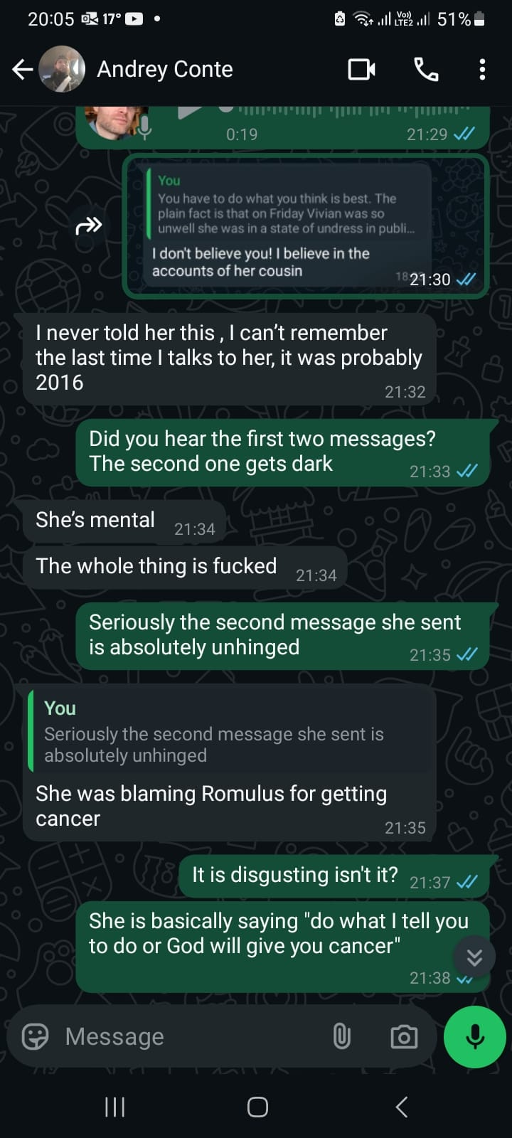
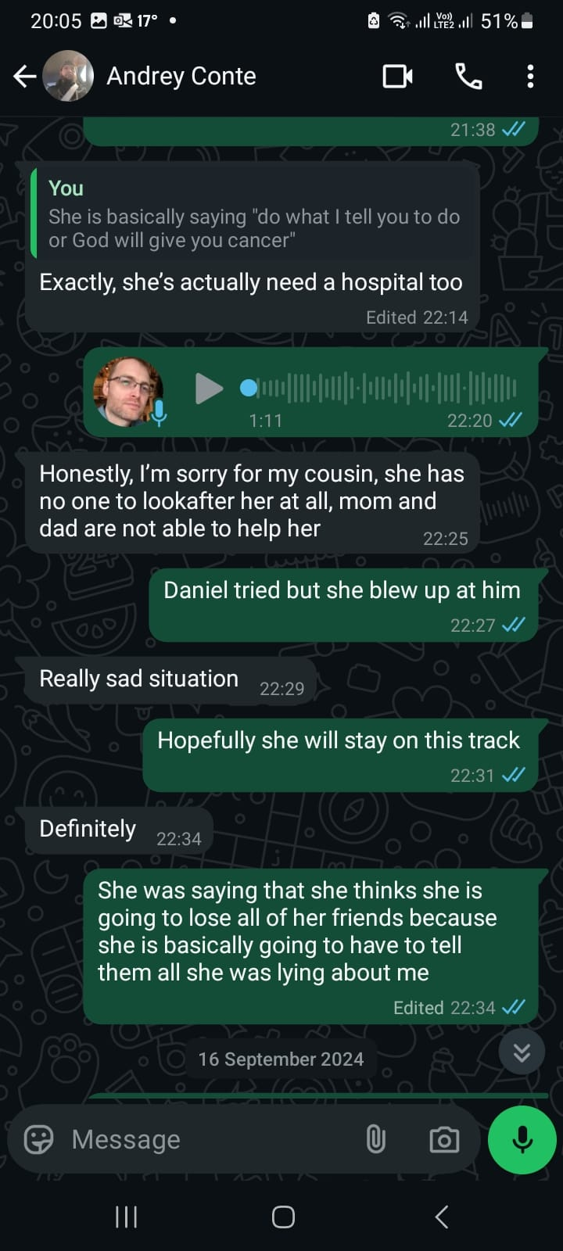

Reacting with surprise when Vivian got hospitalised almost immediately after returning to the US, and encouraging Vivian to drive despite the risks

Coercive Influence Leading to Unsafe Repatriation and Hospitalisation Risk
Shortly after Vivian's discharge from her second UK hospitalisation in September 2024, she was encouraged by Mrs Solange Richardson to return to the United States, despite explicit medical advice recommending a period of stability before making any major life decisions. Vivian’s attending clinician at Sherwood Oaks Hospital, Dr Gemma Ford, advised a minimum two-month recovery period, during which time Vivian was to remain in a supportive and familiar environment. I had been providing that continuity of care and housing.
At that time, Vivian was unequivocally opposed to returning to the U.S., citing deep concerns about her mental health and uncertainty over her UK immigration status. While her Domestic Abuse Visa application was filed during a period of psychiatric instability, and was arguably flawed, it remained potentially salvageable due to her medical circumstances. Dr Ford believed there was room for compassionate consideration by the Home Office, and we were primed to explore legal options.
However, following renewed contact with Mrs Richardson, Vivian abruptly reversed her position. Her prior characterisation of her mother as “terrible for her mental health” was replaced by an uncharacteristically emotional defence of her, exclaiming “She is my mother!” when challenged. This sudden and drastic shift raised red flags around potential coercive influence at a time of psychiatric vulnerability.
Despite her fragile state, Vivian was persuaded to travel internationally, a significant logistical and emotional undertaking, and upon arrival in the U.S., was hospitalised almost immediately. This sequence of events strongly suggests that her decision to return was not grounded in medical readiness or informed choice, but rather in emotional manipulation and pressure.

Encouraging Vivian to void her UK Visa Application
It is also important to note that Mrs Richardson was fully aware that Vivian’s return to the U.S. would invalidate her pending UK visa, effectively closing off a pathway to a more stable care environment and future opportunities. Encouraging such a move under these circumstances was not only clinically inadvisable, but potentially harmful and destabilising.
These events raise serious safeguarding concerns about undue influence, disregard for medical guidance, and the use of familial pressure in a manner that directly jeopardised a vulnerable adult’s recovery and legal status.

September to November 20205 - Coercive Disruption of Stabilisation Plan and Disregard for Immigration Consequences

After re-establishing contact with Vivian during her recovery period in the UK, Mrs Solange Richardson immediately began urging her to return to the United States, despite explicit medical advice recommending that Vivian make no major life decisions for at least two months. At that time, Vivian was still stabilising under clinical supervision and had consistently expressed a clear desire to remain in the UK. Her principal concern was that, during a period of psychosis, she had filed for a UK Domestic Abuse Visa, which she feared might now be declined. She dreaded the idea of returning to the U.S., believing it would destabilise her recovery.

Despite the questionable grounds on which the visa application had been submitted, both Vivian’s clinical team and I believed that—with appropriate legal advocacy—there remained a strong likelihood of success. Dr Gemma Ford of Sherwood Oaks Hospital expressed confidence that the UK Home Office would show flexibility, given the mental health context and supporting documentation.

Nevertheless, following renewed contact with her mother, Vivian underwent a stark reversal in attitude. Previously resolute in her belief that her mother was “terrible for her mental health,” Vivian suddenly insisted, “She is my mother!” a shift that appeared more emotional than rational and raised concerns about suggestibility and emotional manipulation. It is important to emphasise that Mrs Richardson was fully aware that Vivian’s departure would void her visa and jeopardise her legal ability to return to the UK effectively closing off access to continued care and independence.

16th November 2025 - Hospitalisation in the US
Vivian arrived in the United States on 3rd November 2024. Within less than two weeks, she was again hospitalised in a state of acute psychosis. Despite having been repeatedly warned of Vivian’s deteriorating mental condition prior to departure, Mrs Richardson expressed apparent surprise at her rapid decompensation. She then began speaking about needing to travel to Brazil for her own healthcare needs and sought my help in managing Vivian’s care despite having just undermined a carefully coordinated treatment and visa plan in the UK.

This outcome was not only foreseeable but avoidable. I had made clear to Mrs Richardson that had Vivian remained in the UK until February 2025, a visa decision was expected. If granted, it would have allowed Vivian to travel freely between the UK and U.S., preserving both autonomy and access to consistent care. Instead, Mrs Richardson insisted on immediate repatriation, knowingly voiding a visa process that had cost Vivian over $5,000 and significantly limiting her future options. This decision appeared driven not by concern for Vivian’s wellbeing, but by a desire to reassert control and force dependency.

Mrs Richardson’s later reaction, placing the burden on me to solve the resulting crisis, exemplified a broader pattern of cognitive dissonance and refusal to accept responsibility. Her grasp of events appeared distorted, as if the version of events she preferred had supplanted reality. This not only complicates collaborative care but raises legitimate questions about her insight and suitability to act as the primary support figure for a vulnerable adult with complex mental health needs.

These actions cumulatively suggest coercive interference, disregard for clinical recommendations, and potential emotional abuse. APS should carefully evaluate whether Mrs Richardson’s influence on Vivian’s decisions, particularly at critical points of recovery, has contributed to cycles of destabilisation, dependency, and preventable harm.

Solange’s Disregard for Safety in Favour of Material Interests
Following Vivian’s hospitalisation in the US, one of Mrs Solange Richardson’s first stated priorities was ensuring that Vivian had her own car. Her reasoning appeared to centre on protecting her own vehicle (which she considered to be her most valuable possession) from potential damage should Vivian relapse. This raises significant concern. Mrs Richardson openly acknowledged the risk that Vivian, if unwell, could drive in a dangerous manner. Yet her focus was not on the threat such driving might pose to Vivian herself, to public safety, or to others on the road, but solely on the potential loss of personal property.
I immediately made my opinion clear that I believed it would be a disaster for Vivian to get a car whilst she was this unstable, particularly given her track record of driving extremely dangerously whilst sick. Mrs Solange Richardson ignored this and helped Vivian get a car shortly after she was released. This decision, made in the immediate aftermath of acute psychiatric crisis, appears to have been driven by a desire to restore Vivian’s financial productivity rather than prioritise her safety or therapeutic recovery.
Such actions suggest a troubling misalignment between Mrs Richardson’s priorities and Vivian’s clinical needs. APS should evaluate whether decisions like these reflect impaired caregiving judgment, and whether they place a vulnerable adult at unacceptable risk of harm, both to herself and to others.

17 November 2025 - Vivian’s Expression of Regret and Early Signs of Reconciliation Before Relapse
It is also important to note that during Vivian’s hospitalisation following her return to the U.S., she asked for me to call her and immediately expressed regret about having left the UK. She spoke about wanting me to collect her and help her return to the UK, indicating that she was confused or overwhelmed in making the decision to leave. I encouraged her to pause and reflect, as she had made several major life changes in a short period of time and was still in a vulnerable state. During this time, Vivian resumed wearing her wedding rings and was fully reconciled with me for several weeks. We had been planning for me to visit and were discussing the possibility of me moving to the US. However, within a month, the familiar cycle of illness and instability began to re-emerge.

Incident Involving Solange Attempting Harm to Neighbourhood Dogs and its Impact on Vivian's Mental Health Stability
On 14th December 2024, law enforcement was dispatched to the residence of Mrs Solange Richardson following a report that she had been attempting to poison local dogs. According to the attached police report (‘Item 14 - Police visit after dog poisoning 14th December 2024 - SKM_C360i25050522360.pdf’), Mrs Richardson had deliberately placed mothballs on her lawn in areas accessible to neighbourhood animals, resulting in a neighbour’s dog ingesting the substance and becoming seriously ill.
This incident not only raised concerns about Mrs Richardson’s conduct and judgement, but also had a destabilising effect on Vivian. During the ensuing street confrontation with neighbours, Vivian was drawn into the conflict. In the aftermath, she expressed feelings of being abused by both her mother and myself, a marked shift in perception that appeared disproportionate to recent interactions.
At the time, Vivian and I had been progressing toward full reconciliation. However, within days of this incident, she became increasingly withdrawn and began distancing herself from me, which marked the beginning of another deteriorative cycle. This eventually culminated in a psychotic episode in the weeks that followed.
From a safeguarding perspective, this event is deeply troubling. Not only does it suggest a possible lapse in Mrs Richardson’s behavioural stability and capacity for community safety, but it also appears to have triggered significant psychological distress in a vulnerable adult under her care. The incident should be reviewed by Adult Protective Services as part of a broader assessment into Mrs Richardson’s suitability as an unsupervised caregiver to someone with complex and recurrent psychiatric needs.

Escalating Behaviour and Verbal Volatility Following the Dog Poisoning Incident
Shortly after the public altercation with neighbours, while Vivian was away from the house, I received a deeply disturbing phone call from Mrs Solange Richardson. During this call, she was in an intense state of rage that, in my view, strongly resembled a psychiatric episode. Her speech was disorganised and volatile. She repeatedly shouted that they “lived in the ghetto” and “this is not the French Riviera,” despite the area being a quiet and well-kept neighbourhood. She launched into a tirade against the entire community, referring to the neighbours as “garbage” over and over again.
Throughout the call, she seemed to be moving between rooms or possibly outside. At times it sounded like she was yelling openly into the street. It was during this conversation that she admitted she had deliberately placed mothballs on her lawn to target the neighbours’ dogs, whom she accused of fouling her property. At the time I had assumed she had placed them there as a deterrent (I had thought they must be repelled by the smell) but I have since learned it is commonly known that dogs are attracted to eating them, and that they are poisonous to dogs. I very much doubt she was unaware of the threat they posed to dogs and she is a dog owner herself. She expressed no remorse for the harm caused, indeed, she justified her actions as proportionate and showed no empathy for the animal that had become ill.
I only learned the full extent of the consequences, including the dog's poisoning, upon reviewing the subsequent police report. While I have previously witnessed Mrs Richardson act out of spite, I found this incident particularly alarming given her professed love for dogs and the fact that she is a dog owner. This behaviour suggests a troubling escalation in both disregard for others and potential loss of internal moral restraint.
During the call, I pleaded with her to temper her anger, warning that such extreme emotional outbursts could have a detrimental impact on Vivian’s mental health. Her lack of awareness about how her instability might affect her daughter combined with a demonstrable inability to regulate her behaviour, raises urgent safeguarding questions. This episode further supports the need for Adult Protective Services to assess Mrs Richardson’s psychological fitness and the ongoing appropriateness of her role as Vivian’s caregiver.

Incidents involving local garages leading to a divorce petition:

Escalation of Pressure and Paranoia Over Vehicle Repairs
Following Vivian’s abrupt departure from the Clinical Wellness Center after just one day of treatment, Mrs Solange Richardson immediately began pressuring her to prioritise repairs to her vehicle, specifically a malfunctioning sunroof. Vivian brought the car to a local dealership, where she was informed that a proper investigation would require approximately three days. However, Mrs Richardson soon became consumed by paranoid suspicions, convinced, without any evidence, that the dealership intended to strip the vehicle for parts. Acting on these fears, she insisted on accompanying Vivian back to the dealership, where, according to Vivian, Mrs Richardson verbally abused the staff, “cursing them all off” and demanding the vehicle was returned. As a result of the confrontation, the dealership returned the vehicle without completing the assessment.

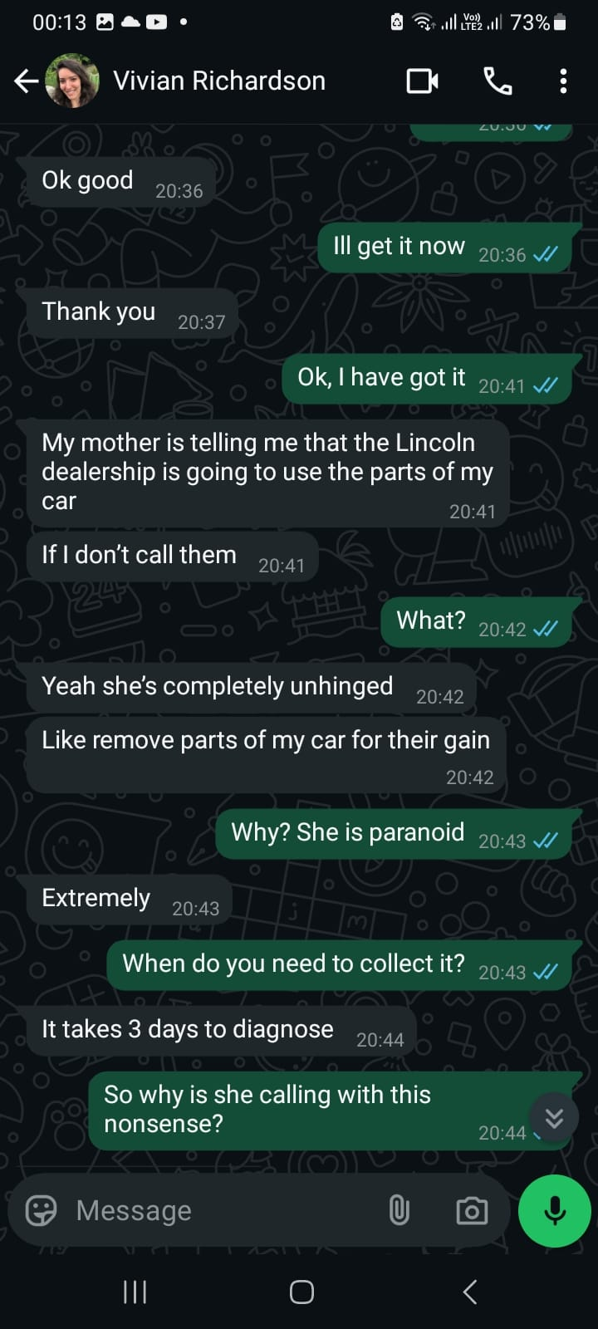
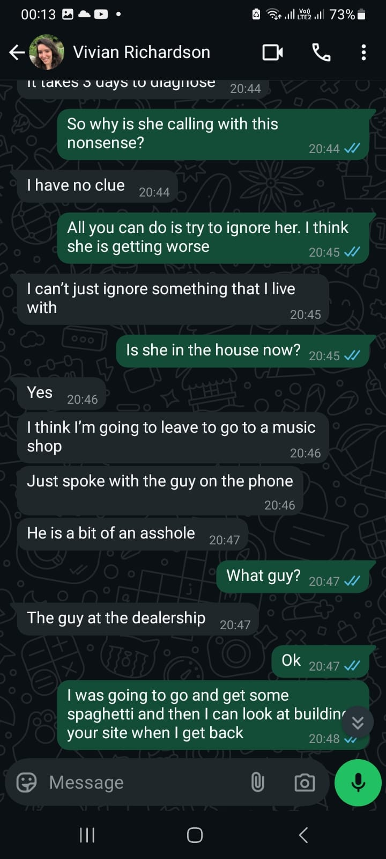

Unsafe Expectations and Emotional Distress Over Car Repairs
Following the confrontation at the dealership, Mrs Solange Richardson insisted that the sunroof could be repaired at home using a part ordered online. Despite the complexity of the task, clearly one best suited for a trained mechanic, Mrs Solange Richardson pressured Vivian into attempting the repair herself. Unsurprisingly, the task proved unmanageable. At one point, Vivian seemed very strained and frustration, Vivian described the experience as “torture.” This incident reflects a pattern of inappropriate expectations being placed on Vivian, particularly at a time when she was still in a vulnerable and unstable mental state.

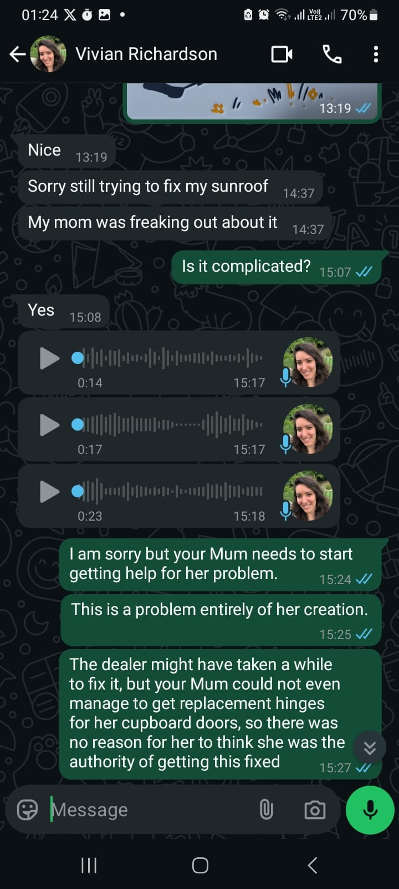
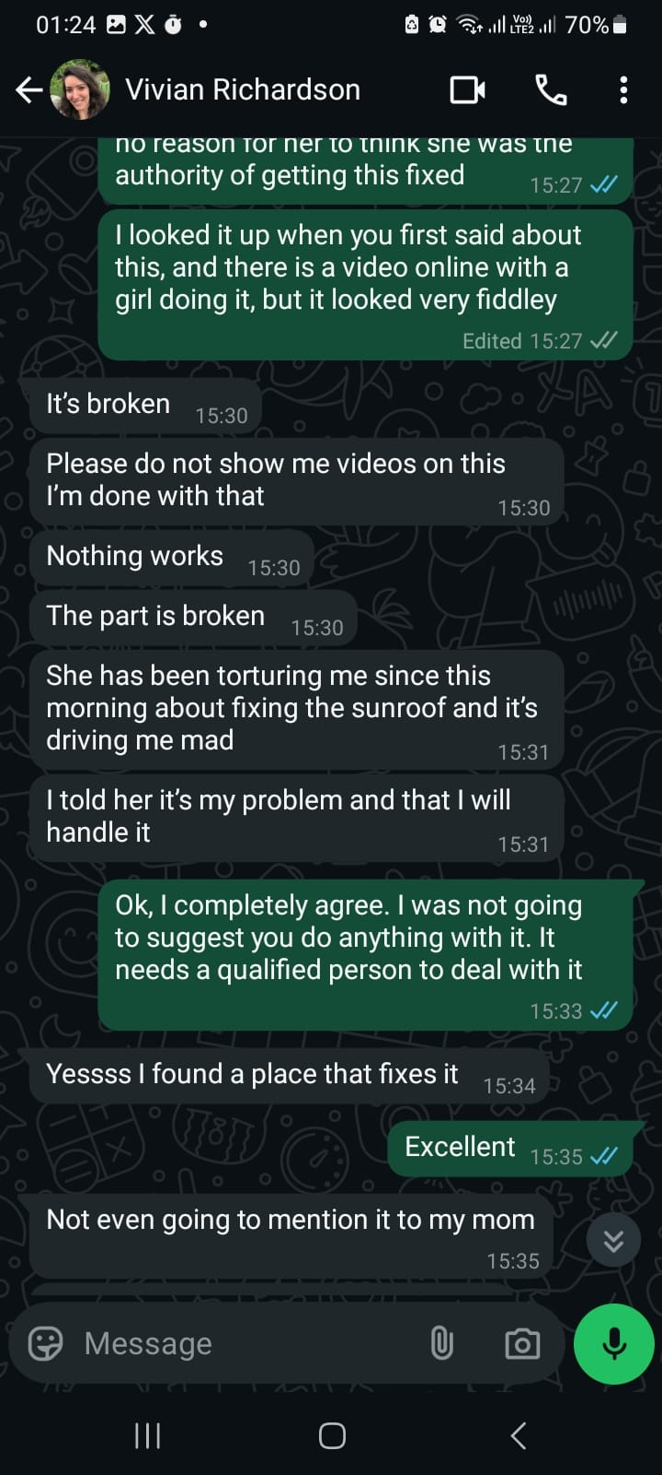

Eventually, Vivian arranged to take the car to a different mechanic, leaving the house without informing her mother. I had no involvement in this decision, nor did I encourage it. Given the escalating tensions and the likelihood that I would be blamed if anything went wrong, I deliberately avoided becoming involved at that stage. Unfortunately, this alternative arrangement also broke down. The mechanic attempted to charge Vivian significantly more than the original quote, which led to a dispute. Vivian was already showing signs of agitation by this point. At one stage, I offered to help de-escalate the situation and suggested a group call between myself, Vivian, and the garage owner. During this call, Vivian began screaming early on and displayed clear signs of emotional instability. Although no agreement was reached at the time, I offered to contribute financially, sending Vivian $800 (which was all I could afford at that point) and committed to covering any remaining costs in the following months. I did not feel that I had achieved much in the call, but shortly afterwards, a compromise was reached: Vivian agreed to pay $195 for the initial investigation.

Later that evening, the mechanic contacted me and asked me to inform Vivian not to return to the garage before 12 p.m. the next day, as the car was still being reassembled. Vivian, however, told me she intended to go at 8 a.m. with her mother. I was wary about that prospect and attempted to set expectations, but I had no authority over the situation. I was also committed to an important business meeting that morning and could not intervene directly. My expectation was that given both Solange and Vivian’s volatility at that time, it was likely something unfortunate was about to happen, and that is what came to pass.

31 March 2025 - Second Garage incident involving Solange

The following morning, Vivian and her mother arrived at the garage at 8 a.m. By Vivian’s account, her mother became verbally aggressive, shouting at the staff and ultimately calling the police. According to the garage owner, Vivian herself was also behaving inappropriately. Vivian denied this, but based on past episodes, it would not be unusual for her to have difficulty recalling the nature or intensity of her own behaviour during a distressing outburst.

After the altercation, Mrs. Solange Richardson drove Vivian directly to the courthouse and instructed her to take legal action against the garage. She then abandoned Vivian there. Shortly afterwards, I began receiving messages from Vivian stating that her mother had cost her a significant amount of money by escalating the situation by “cursing off” the staff and provoking the garage owner into rescinding the reduced settlement. The owner was now demanding $1,200.

Minutes afterwards, I received a series of abusive and irrational voice messages from Mrs. Solange Richardson. In the first, she demanded that I call Vivian an Uber, having just abandoned her at the courthouse because, in her words, “she was going to destroy my car.” This was yet another instance in which Solange appeared to prioritise her vehicle over Vivian’s safety. It was also yet another example of Solange acting rashly and then expecting me to manage the consequences. She went on to say that “if something happens to Vivian,” she would hold me personally responsible, a claim that was both irrational and completely devoid of accountability. She also blamed me, Vivian’s father, and Vivian’s brother for the situation, despite the fact that the original dealership might have resolved the matter amicably had she not previously abused the staff. She further insisted that I should have stopped Vivian from making independent decisions without consulting her, revealing a deeply troubling belief in her entitlement to control Vivian’s choices. For someone who routinely denies the seriousness of Vivian’s mental illness, she showed no respect whatsoever for Vivian’s autonomy. Much of what she said was incoherent and illogical. At one point, she claimed the car had been destroyed, but it was just awaiting reassembly. This was a reasonable expectation as they had arrived four hours ahead of the appointed collection time. Vivian drove it home later that same day without issue.

What stood out most was that Mrs Solange Richardson appeared far more distressed over her belief that Vivian’s car had been damaged than she had been just weeks earlier when Vivian was clearly in a state of psychosis and at risk of serious harm. She also appeared convinced that I had somehow advised Vivian not to involve law enforcement or the courts, and sent me a highly abusive message on that basis, despite the fact that she had already called the police and taken Vivian to the courthouse herself, without any involvement from me. Her logic was internally contradictory and deeply paranoid. In tone and content, her behaviour mirrored some of the more extreme episodes I have witnessed in Vivian when she is unwell. I genuinely believe these messages reflect a person suffering from a destructive and untreated mental illness.

Transcript of voice messages sent 31 March 2025
What follows is the full transcript of the messages I received, delivered with escalating rage, paranoia, and delusional fixation on demonic possession. I include it here in full because it is representative of the kind of verbal abuse that both I and, historically, Vivian have been subject to, abuse that I believe constitutes a recurring psychological stressor and potential trigger for Vivian’s deteriorations:

“Get her a Uber. She is in Delray. I'm not going to wait for her. She wants to destroy my car. Now you, you and Jonathan, you created this problem because you're doing things against my back. She was not supposed to do what she did, but you encouraged her to do what she did. The car is absolutely destroyed. The man, it is a scumbag. He's a scumbag.
You, you did it. You did it. You or Jonathan or the father. You did it, because you not supposed to encourage her to do anything behind my back. You destroy her car because you can never have a car just like her. You can never have a work like her. So you did it. You did it.
Your works. You are a missionary from the devil. You are the devil. Look, I don't have a good word for you. I don't have a good word for Vivian's aunt. I don't have a good word for Vivian's father. I don't have a good word for Vivian's brother. I don't have a good word for people that comes in her life and do this.
Once she called you that she would bring the car on my back, without my knowledge to this guy, you should say “Vivian, I think you should talk to your mother.” Oh, because my mother is this is that. Use your word. Your word should should be “Vivian, I know that you might disagree with your mother, but she is there and I am not.” And you did not do. You are, you are the one.

Look, you will pay for. You might not be paying for me on my lifetime. But all the misery that you brought to my personal life and my daughter's life will come to you because you are the devil. You are the devil in a, a body and a person's body. You are demonic. You are demonic.
There is no hope for you until you change your attitude. There is no hope for the father and he will never change his attitude. There is no hope for the for my own son. If you do not change, if he doesn't change his attitude and there is no hope for Vivian, if she doesn't change her attitude. Call Uber for her you asshole. You're demonic. Your demonic asshole.
She needs a police report. That was a good opportunity. You don't know shit about American justice. If she goes to court for any reason that she doesn't have a police report, she has no case. I've been in this country more than you being alive here, asshole. You're demonic.

If something happens with Vivian, I will be. I will be making you a criminal. You're guilty. You're guilty because you are, first of all, I have no idea how in the name of God you are in another country having a American, a South Florida phone number.
You are a criminal yourself, so if something happens to her, you will be charged because I will make sure. I'll tell the story. You are a scumbag criminal yourself. You or you have nothing to do. You're a loser. You don't help. You don't wanna help. You came to destroy, because since you came, you destroyed. You have not build up anything.

You are a criminal. You are a scumbag. You are worthless.”

Further Evidence of Emotional Abuse and Psychological Risk Posed by Mrs. Solange Richardson
The full recording is at https://adjustableproductions.com/apsevidence/Mrs_Solange_Richardson_Outburst_31st_March_2025.mp3

It is critical that the linked recording be reviewed in full. The tone and intensity it captures are representative of the environment Vivian is frequently exposed to when her mother, Mrs Solange Richardson, becomes agitated or confrontational. I would ask that you listen carefully to this message and consider the psychological impact such outbursts may have had on Vivian, particularly in past situations where she was attempting to access mental health support such as when she was trying to attend the rehabilitation program.

This recording illustrates a pattern of behaviour that I believe constitutes ongoing emotional abuse. The content is marked by controlling, paranoid, and accusatory language, as well as a repeated tendency to deflect personal accountability. At one point, Mrs. Richardson claims that my use of a US-based forwarding number (which I maintain for emergencies) proves that I am a criminal. These kinds of conclusions are not just irrational; they reflect a disturbing pattern in which she appears to construct elaborate, delusional narratives in order to justify anger and hostility. The intensity of her conviction in these moments is especially concerning and may give insight into what Vivian has been subjected to within the household.

This level of verbal aggression and emotional volatility is not uncommon in my experience of interacting with Mrs. Richardson. It is consistent with what several estranged members of her own family have described and, in my view, reflects behaviour that is not merely eccentric or difficult, but indicative of an undiagnosed and unmanaged mental health condition. Of particular safeguarding concern is her repeated pattern of attributing demonic or evil intent to others simply for not complying with her expectations. In this message, for instance, she refers to me as a "demon" and a "missionary from the devil." These are not expressions of religious belief in the usual sense; they are evidence of a rigid and delusional worldview in which disagreement is equated with moral evil.

I believe that this behaviour poses a significant risk to Vivian’s mental stability and autonomy. Having witnessed firsthand how such dynamics have coincided with periods of psychological deterioration in Vivian, I am concerned that she cannot exercise meaningful personal agency or make independent decisions while under the influence or control of her mother’s behaviour. The recording is not an isolated incident. It reflects a chronic pattern that, in my opinion, significantly compromises Vivian’s emotional safety and undermines her ability to recover and maintain psychiatric stability.

Vivian’s Changing Position on Holding Her Mother to Account
As a consequence of the incident, the garage owner became furious about what had transpired and rescinded his earlier offer to settle the matter for $195. Instead, he reinstated the full charge of $1,200. I attempted to negotiate a compromise, but he remained firm. As mentioned, prior to this I had already committed to helping Vivian cover the cost and had sent her $800 with the intention of covering the remainder over the following months.

Following the confrontation at the garage, Vivian chose to stay away from home for a few hours. During our conversations that afternoon, she was highly critical of her mother’s actions and expressed frustration about how the situation had been handled. However, after returning home later that day, her attitude abruptly shifted. Whereas she had previously held her mother responsible for escalating the situation and causing the loss of the negotiated deal, she now began to minimise her mother’s role and changed the tone of our conversations significantly.

Impact on Vivian and the Sudden Move Toward Divorce
Following the incident at the garage, Vivian began to distance herself from me emotionally. During one exchange, on the evening of 31 March 2025, in response to Vivian despairing at the situation, I raised concerns about her mother’s recent behaviour, in particular, the lack of justification for verbally abusing the garage staff, and the pattern of escalating crises that had interfered with Vivian’s ability to access support when she needed it. Vivian responded with sudden and intense anger at the suggestion that her mother had played any role in the problems. She insisted that I was defending the garage and declared that we would need to get a divorce.
Her language during this time became increasingly distressed and echoed some of the religious or conspiratorial phrasing I typically associate with Mrs. Solange Richardson, saying she was “terrified of this demonic guy!” an that “it’s in God’s hands now.” I reassured Vivian that I was still willing to pay the full cost of the car repairs simply to resolve the situation and reduce her stress.
We had a brief 53-second phone conversation in which I remained calm, but Vivian sounded agitated. After the call, she accused me of yelling at her, which I had not done. Vivian again insisted that I was wrong to assign any blame to her mother. She said I was siding with the mechanic and called him a “coward and a POS.” It was at this point that she reiterated her decision that the only option was divorce.

Signs of Lasting Influence of Solange’s agitation
Although it is clear that tensions were high, it is also reasonable to state that Mrs. Richardson was a key antagonist in this situation, and acknowledging her role was not unfair. The following day, Vivian seemed calmer in text exchanges, however In the early hours of 2 April, she sent several distressed messages, which I did not see until later in the morning. When I contacted her, she explained that she had woken at 2 a.m. and had been unable to sleep, describing the experience as “just horrible.” I reminded her that clinicians at South County Mental Hospital had specifically advised her to contact them at the first sign of sleep disturbance. She replied that this was not due to mania and therefore saw no need to reach out for support.
Concerned that this might signal early signs of relapse, I attempted to check in again later that day. Her messages rapidly escalated in hostility. She accused me of being a “coward,” blamed me for “siding with the scammer,” and then sent a series of angry and abusive messages. She also attempted to call me repeatedly. For the first time in our relationship, I made the decision not to answer the phone because the tone had become so aggressive. Despite my attempts to remain calm and supportive, she continued to send increasingly hostile messages, including calling me a “fucking coward” and saying she “fucking loathed me.” She again stated that we needed to divorce and instructed me to begin proceedings the following day.
At one point, Vivian wrote:
“I’m coming to terms with this anger of mine. And I realize it is because of you. We need a divorce.”
I found this particularly alarming, as I had done nothing other than be supportive and attempt to de-escalate the situation and provide support. Meanwhile, her mother had behaved in a way that was clearly destabilising. Nevertheless, on 8 April 2025, Vivian filed a petition for divorce.

Possible Pressure for Solange Leading to Divorce Filing

In my view, a significant shift occurred in Vivian’s outlook and decision-making following her return to her mother’s home on 31 March 2025. Up until she returned home Vivian had been openly critical of her mother’s role in the events surrounding the garage incident. However, after returning home, her tone changed rapidly and markedly. Given the level of hostility and accusatory language Mrs. Solange Richardson had directed at me earlier that day, including voice messages that were both intense and deeply personal, it is reasonable to be concerned that this dynamic may have created an emotionally volatile environment for Vivian, particularly at a time of stress when her messages indicate she was struggling with her stability.

Mrs. Richardson has a documented pattern of aggressive communication and has previously taken steps to isolate Vivian from other family members, often by framing them as hostile or untrustworthy. In this context, it is plausible that Vivian felt pressure to change her position and align with her mother’s narrative. I am concerned that this shift may not reflect Vivian’s fully autonomous decision-making, but rather the result of sustained emotional influence and the fear of losing housing or support.

The speed of Vivian’s reversal — from expressing distress about her mother’s conduct to defending her actions and rejecting mine — occurred within a matter of hours. This change followed a period of escalating pressure and coincided with ongoing volatility in the home environment. It is also important to note that Mrs. Richardson had recently driven Vivian to the courthouse herself, urging her to initiate legal proceedings against a third party. This demonstrates the degree of persuasion or influence Mrs. Richardson may exert over Vivian’s actions during periods of emotional stress.

Taken together, these events raise safeguarding concerns about the extent to which Vivian is able to make independent decisions in an environment marked by instability, emotional coercion, and conflicting narratives. I have included all relevant WhatsApp messages between myself and Vivian during this period as ‘Item 15 – WhatsApp messages between Vivian and Robert, 28 March – 8 April 2025’.
In my view, what changed between Vivian’s initial response to the incident and her later actions was her return home to her mother. Given the unbridled rage Solange had displayed about me just a few days prior, and given her track record, I think it is reasonable to expect that Mrs Solange Richardson likely continued her angry and delusional commentary and non-stop badgering about me and may have created an intolerable environment for Vivian. I suspect Vivian may have feared being forced out of the house if she expressed any disagreement with her mother. Given Mrs. Richardson’s past messages and behaviour and history of estranging Vivian from her own family, it is entirely plausible that she influenced or pressured Vivian into filing for divorce.
Vivian’s complete reversal, from blaming her mother to protecting her and attacking me, occurred within a very short time frame. It is especially striking considering that Mrs. Richardson herself had driven Vivian to the courthouse just days earlier to urge her to take legal action against the garage owner. This context raises serious concerns about Vivian’s ability to exercise full personal agency in a volatile and coercive household environment.
All relevant messages between myself and Vivian during this period are included in ‘Item 15 – WhatsApp messages between Vivian and Robert, 28 March – 8 April 2025’.

Over the coming days Vivian began to seem to alienate from me again. At one point I reminded Vivian that her mother had no reason for acting the way that she had done, there was no possible benefit to her abusing the garage staff, that she had caused multiple problems in the past few weeks with many consequences, including preventing Vivian getting help when she needed it. Vivian suddenly expressed anger that I could be putting any blame on her Mother. Vivian said that I was defending the garage, and that we had to get a divorce. Vivian’s language around this time was quite distressed and at times she too was talking in terms of people being “demonic” and things “being in the hands of god now”. This is normally the kind of language I would associate with her mother.

I told Vivian that I was still happy to pay the full amount just so we could bring the matter and associated stress to a close. We had a 53 second phone conversation where I was completely calm and Vivian was very agitated. After the call Vivian accused me of yelling at her, which I had not. Vivian’s response was to say that it was wrong to blame her Mother for anything, that I was siding with the mechanic who was a “coward and a POS”. It was that moment she said that the only option was to divorce me.

It is fair to say that Mrs Solange Richardson was a major antagonist in this situation and it was not unfair for me to point that out. The next day Vivian exchanged some messages with me where she seemed a bit calmer. I received distressed Whatsapp text messages from Vivian early on 2nd April, but I did not see them until hours later. I reached out to Vivian. She told me that she had woken up at 2am and had been unable to get to sleep and it was “just horrible”. I reminded Vivian that her clinician at South County Mental Hospital had advised her to contact them for help at the earliest sign of a seriously disturbed night’s sleep. She replied saying that it was not due to mania, so she would not be contacting them.

I was concerned that Vivian may be having developing problems, so later that day I reached out to her again. Her responses escalated in anger again. She said I was a coward and that I had blamed her mother and “sided with the scammer”. This quickly blew up with her sending me abusive messages and trying to call me over and over again. This was a very rare occasion where I refused to pick up the phone to Vivian because I did not feel like receiving verbal abuse. I was reasonable and calm throughout the exchange, but Vivian was abusive. She kept on calling me a “fucking coward” and said that she “fucking loathed me.” She again mentioned divorce, saying she wanted me to start a divorce tomorrow. The tone of her messages was in keeping with what I would associate with her suffering from the effects of her illness. At one point Vivian said “I’m coming to terms with this anger of mine. And I realize it is because of you. We need a divorce.”

It is alarming that Vivian could somehow reached that conclusion given that I had done nothing but try and calm the situation down, and her mother had been out of control. In spite of that, days later on 8th April 2025, Vivian completed filing a petition for divorce.

My honest opinion is that when Vivian returned home, her mother continued her deluded rants about me and had made Vivian’s life hell. I suspect Vivian was in fear of being made homeless if she continued to put any blame on her mother. I think given her mother’s messages to me, there is every possibility she put Vivian in a position where she felt she had to begin divorce proceedings. It is hard to understand how Vivian completely changed her position on her mother’s role in the debacle. Given that she literally drove Vivian to the Court house to force her to take action again the garage owner, I would not be surprised exercised undue influence over Vivian to create an environment where she felt she had no choice but to proceed the petition.

I have included all of my Whatsapps text messages between myself and Vivian in ‘Item 15 - Whatsapp messages between Vivian and Robert between 28th March 2025 and 8th April.pdf’

Mrs Solange Richardson’s constant talk of devils and demonic possession:

I have noticed that it has now almost become second nature for Mrs Solange Richardson to consider anything that goes against her wishes to be affected by devils or demonic possession. For example, when I visited them in late January 2025, her dog Bruno attacked her and was behaving out of character. I was strongly suggesting that she contact the vet, but it took some persuasion. There was constant talk of “a devil getting into this dog” and having to have it put down long before she sought any help from the vet.

I know that Mrs Solange Richardson has in the past told people that she believes I have been sent by the devil to keep Vivian from the Church. However, as I have shown, in the last few months she has gone as far as telling her son Jonathan Richardson that I am “the enemy” (the devil). She has since sent me aggressive and abusive messages when she rants that I am “demonic” and “the devil”. I have heard her refer to Vivian’s father Daniel Richardson as “demonic”. I have heard her refer to her gay neighbours as “demonic”. I think any challenge she faces, she seems to start talking about the devil being involved. It is a constant theme, and in my opinion it goes beyond religious belief and is more religious delusions. She frequently claims the Bible says things that would give her control of situations. Worryingly, in recent times, Vivian has started echoing this sort of behaviour. I suspect this may be directly related to fear of the consequences if she does not do this.

Mrs Solange Richardson constantly shows paranoia towards her neighbours who she believes are always watching her when she goes out of the house. She talks as if she is constantly being persecuted and is in an ongoing battle with the devil and manifests in lots of everyday challenges and well as other difficulties she faces. She acts as if she herself is in a rolling state of crisis.

Raging about Vivian’s father, Daniel Richardson:

When I visited Vivian in Boynton Beach in January, there were two incidents where Mrs Solange Richardson started to become quite irate about Vivian’s father Daniel Richardson. One was when we were on our way to collect Vivian from the hospital. Mrs Solange Richardson seemed angry that I was trying to maintain a good relationship with him, and she listed her grievances against him. When I said I just wanted to be a mediator and for Vivian’s sake she should not be exposed to this kind of agitation, she just became more intense, as if having my own mind of this subject was unacceptable. By the time we got to the hospital she seemed quite angry, and I was really quite concerned how she was going to be with Vivian when we collected her. However, she snapped out of it and was calm once we got out of the car. It was extremely stressful to be on the end of this barrage. Mrs Solange Richardson did not really seem to appreciate how intense she was, or how unpleasant the situation was.

On Monday 3rd February 2025 there was an unfortunate incident whilst Vivian was out at work and I was at home with Mrs Solange Richardson. We went from having a polite conversation to her again becoming uncontrollably angry about Vivian’s father, Daniel Richardson. Over the course of an hour she became ever more angry and snarling, clenching her fists, and shouting about all of her grievances with him. I found it very distressing. I felt Mrs Solange Richards was trying to bully me into having a certain negative opinion of Mr Daniel Richardson. I maintained the position that Vivian wanted to stay in contact with her Father, that I can not get involved in her old arguments with her ex-husband, that I just wanted to be a mediator, and that for Vivian’s sake she should not be showing this kind of anger in front of Vivian. In the end I broke down in tears and walked away from her. Mrs Solange Richardson later messaged me and did show a level of contriteness.

I am concerned that Mrs Solange Richardson might be using these kinds of tactics to manipulate Vivian and shape her opinion of myself, her father and other in the family that she has already burned her bridges with.

Abuse that I strongly suspect is happening:

Fits of rage used to support controlling behaviour:

I have witnessed Mrs Solange Richardson exhibiting erratic fits of rage on multiple other occasions. In the past exposure to such fits have caused Vivian to go into the early stages of illness. Mrs Solange Richardson constantly uses unpleasant fits of anger and bullying tactics to try and get her way, including on matters that have nothing to do with her. She is even prone to having such fits of anger in public, often leaving the people she dealing with bewildered. There is a sense of never quite knowing if she is about to explode, particularly if something is going to go against her wishes. I moderate my conversation and tread carefully with her to try and avoid explosive events, but I have still been on the end of aggressive outbursts. I have no reason to doubt that Vivian is suffering such behaviour from Mrs Solange Richardson, and indeed it was confirmed with her conduct when she tried to prevent Vivian going to the Clinical Wellness center.

Taking advantage of Vivian’s vulnerable state to take control of her

We know that in the past Mrs Solange Richardson has tried to take advantage of Vivian being in the early stages of illness to try and control of her. In June 2021, Whilst I was in the UK and Vivian was in the US, I made Mrs Solange Richardson aware that I felt Vivian might be getting unwell. Mrs Solange Richardson immediately got Vivian to cut off our conversation and then took her on a walk telling her that Vivian “did not know me” and that I would “lock her in a cupboard”. Vivian then split with me for two days, before coming to her senses and restarting our relationship.

Past isolation from her father and paternal family

Mrs Solange Richardson has a long history of controlling and abusive behaviour towards Vivian. Many of her family are estranged from her or keep their distance from Mrs Solange Richardson. Vivian has previously told me that she was prevented from seeing any of her paternal family between the ages of 7 and 17 years old. Vivian was prevented from seeing he own father in those 10 years. In the past Mrs Solange Richardson has shown such bitterness and spite towards her own family that she has cut her own face out of their family photos and has destroyed family videos. I would say that she probably wishes to be a good and supportive mother, but she constantly tries to impose her own selfish will on Vivian under the guise of it being Biblical wisdom. It is my opinion that Mrs Solange Richardson is compromised by a pathological malevolence that brings chaos and disharmony to the lives of the few people that remain close to her.

There was also an incident in 2021 where she decided she did not want Vivian to talk to me any more and she called the local sheriff like he could force Vivian to stop talking to me. It sounds almost too banana’s to consider that it actually happened, but it did. She had no respect for Vivian just having autonomy to wish to talk to me.

Car ownership incident

In early 2021, Mrs Solange Richardson also had Vivian transfer her car ownership into her name, ostensibly for insurance purposes. In August 2021 Mrs Solange Richardson tried to stop Vivian having driving in her own car, by telling Vivian the car belonged to her and that she would report it to the police as stolen if she did not return it. This was frankly vile controlling behaviour. She had also opposed Vivian coming to visit me in the UK. We had three weeks together in both the UK and an Air b’n’B in the US. When Vivian made a visit to her home to pick up some things she needed, her mother informed her she had written her out of her will. When I left the US to return to the UK, and Vivian returned to her home with her mother, her mother made her homeless, calling her “a criminal and a prostitute” over and over again. As I have said, I do believe Vivian that is living in fear of being made homeless again.

Vivian’s choice to not contact her mother

Vivian had nearly 3 years between April 2021 and June 2024 where there was no hospitalisations or episodes of acute psychosis. For most of this time, from August 2021 to June 2024, Vivian was living with me. Early intervention was the key to her ongoing relative wellness. Through most of this time Vivian was rationally estranged from Mrs Solange Richardson, and showed no intention of having any contact with her, despite my encouragement to keep up some form of communication. Vivian had always been adamant that her mother was terrible for her mental health and that she would never go on her territory again. Vivian’s psychologist seemed to be of the opinion that it was better for Vivian to avoid contact with her mother, and Vivian described her as “just too much” and abusive in her initial assessments. As I have mentioned, when her doctor (Doctor Jolly) became aware that Vivian was considering leaving the UK to go and live with her mother, he called her in for a couple of appointments. It seems it was am marginal decision whether or not he was going to hospitalise her to prevent her going ahead with the plan.

Final notes

My hope is that by raising this report to the Adult Protective Services, Vivian will at the very least be monitored in future and her mother will not have an unrestricted control over her life. I do believe that her mother would benefit from some kind of mental health support herself, but I doubt that she would accept it. I think Vivian’s safety and welfare must be the priority.

It has been incredibly difficult to try and intervene at times of crisis when Mrs Solange Richardson has been neglecting Vivian. So many times I have found myself working on a UK timezone but sleeping on a US timezone to be able to support Vivian. This has been a very challenging time dealing with her illness, and I feel very sorry that Vivian has had to go through this. However, I do not want to see Vivian alienate herself from those who care for her the most. That is the way that her mother has lived her life, and as a result very people want to deal with her.

I do believe that Mrs Solange Richardson has a fear of Vivian reconciling with me, and us going and ultimately leaving Mrs Solange Richardson alone again, completely estranged from the rest of her family. I think this is influencing how she is dealing with Vivian. I also think she has a pathological need to control Vivian which she articulates through abusive and manipulative tactics. I belief that this aggravates Vivian’s condition, and I believe Mrs Solange Richardson tries to keep Vivian from care so that she can continue to control Vivian. Both Jonathan Richardson and myself share a suspicion that Vivian is being encouraged to progress her divorce in this kind of hostile bullying environment.

I feel there have been many missed opportunities to get help for Vivian in the past. I do not know how much longer I will play any role in Vivian’s life. I do not want to miss this opportunity to try and liberate Vivian from things that have held her back throughout her life.

I hope that this extensive report will be read in that spirit. Vivian is an incredibly special and talented person. She has been subjected to emotional abuse from her mother throughout her life, and her illness has left her exposed to exploitation from so-called “friends”. When I married Vivian I knew it was a possibility we could get into a mess like this. It is extremely unfortunate that I have become the focus of her anger and paranoia, and that the beautiful relationship we had has been torn apart. However, I think given the nature of her problems and the things she needs help to face, it may have been inevitable that I as the one who was closest to her and that feared to lose the most, would be the one who she unloaded all her ire upon.

It is a cruel illness that robs people of the ability to relate to those they love the most. I do not think it is fair on Vivian, and that is why I have persevered when she has cycled through treating me terribly and reconciling as the illness has ravaged her life. She is the most beautiful delicate soul I have ever met. Even when she is unwell she has moments where she suddenly reaches out, and from somewhere within her she tells me that she love me. The last time she was sick, she called me and whilst I was trying to keep her on the line and scramble help to her she said “I just wanted to tell you, I love you. You are my partner and life companion.” Last just December, when she had a few weeks when she seemed to be back to her normal self she sent me the below card:

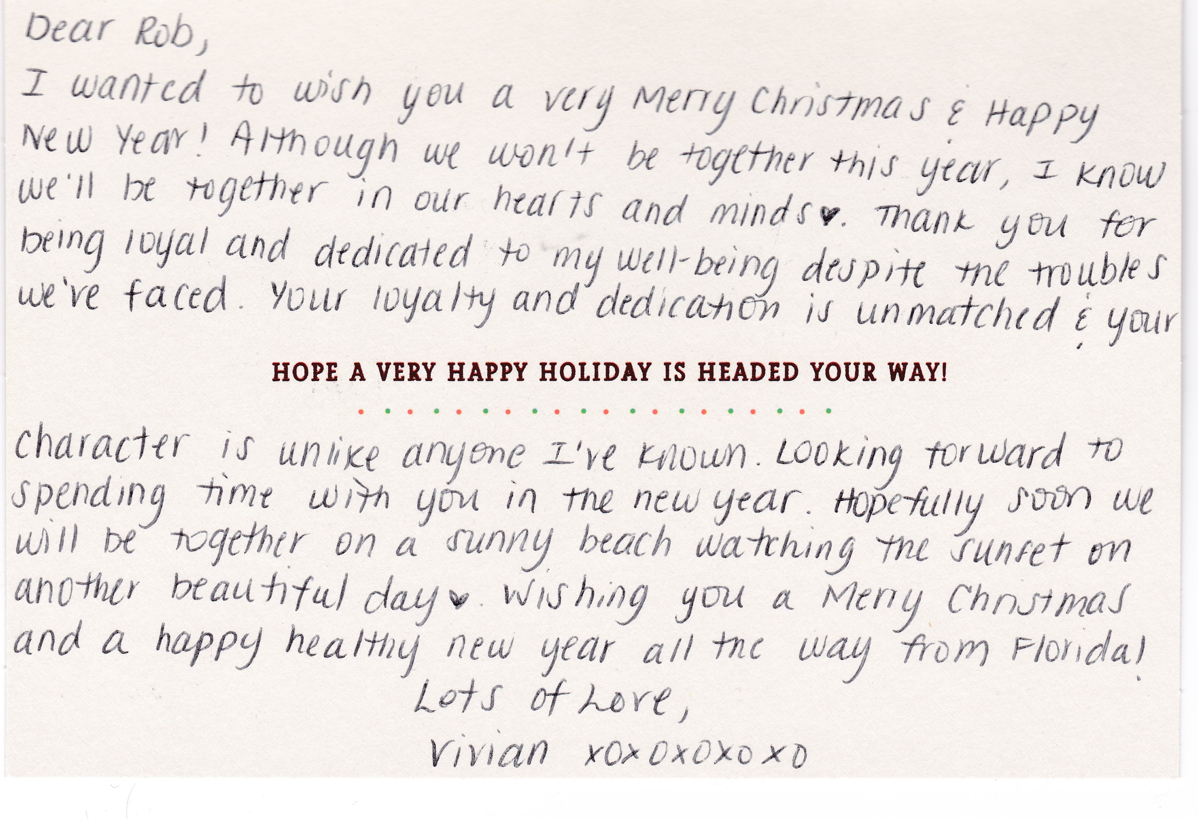
This is now one of my most treasured possessions. By the time I received it, she had already alienated from me again. A month later she was in hospital, and we had a phone call where she was again regretting leaving me and saying she felt like she was living in a “waking nightmare”.

I would ask that you please consider taking an interest in her wellbeing. She deserved to have a happy life, surrounded by people that love her. She just the most beautiful person I have ever known. I know that I might not have a part in her future, but she does need interventions in her life to protect her from the poor judgement of her mother. Even if it is just routine visits to confirm that she is doing ok, she needs some official oversight to protect her.

